REMOTE LEARNING LESSON PLANS
The Remote Learning Lesson Plans are adapted from the IQWST Teacher Edition to support continuous learning. Each plan condenses what is taught with specific teaching recommendations and identifies the digital resources, print resources, and materials needed to teach and learn IQWST remotely.

UNIT TITLE | LS3
DRIVING QUESTION | Why do organisms look the way they do?
UNIT STORYLINE | LS3 Storyline
IQWST OVERVIEW | IQWST 3.0 Overview
TEACHER EDITION | LS3 Teacher Edition (PDF)
STUDENT EDITION | LS3 Student Edition (PDF)
LESSON PLAN OVERVIEW | Remote Learning Overview

STUDENT MATERIALS: Each student will need the following materials. Teachers can modify lessons based on which materials the students have access to. For Blended Learning options, teachers may draw from a combination of digital and print resources.
DIGITAL RESOURCES | PRINT RESOURCES | MATERIALS NEEDED (FOR EACH STUDENT)
- Access to Interactive Student Edition  - Access to teacher-led lesson or video  - Access to IQWST lesson videos  - Audio recordings of readings  Access from any device with a web browser.  - For PCs and Chromebooks, we recommend using Chrome as the browser  - For Macs and iOS, we recommend using Safari as the browser  - Internet Explorer is NOT supported  - Read the full Technical Requirements here  Login: http://activatelearning.com/digital-resources/  - Select your program  - Enter the Username and/or Password provided by your teacher | - LS3 Student Edition  - Hard copies of selected Projected Images (PIs)  Print student editions are necessary for students who do not have internet access (or reliable access). | IQWST Equipment (from kit)*  Pad of sticky notes  (3)pieces of PTC paper  Modeling clay in five colors  Household Items  Flowers  Students may also need the following General Classroom Supplies (if not using the IDE):  Pencils and sharpener  Colored pencils  Black marker and/or ink pen  Plain paper for drawing (10-20 sheets)  Glue stick or transparent tape  Pad of sticky notes  Scissors  * If kits have been purchased, they include enough equipment for 8 groups of 4 students. You will need additional equipment if you opt to provide materials to each student.

Learning Set 1:
Lesson 1  (3 sessions) | The Same and Different You and Me | Download Lesson 1 Teaching Slides
ACTIVITY | TEACHING RECOMMENDATIONS | DIGITAL RESOURCES | PRINT RESOURCES | MATERIALS  FOR EACH STUDENT
Activity 1.1  What Traits Do Humans Have? | Anchoring Phenomenon: Students (Ss) view photos of fish, plants and birds to look for patterns, noting that they have some traits in common and some that are different.  Share PI: Fish and Plants and PI: Birds.  Discuss human traits and variations, and the difference between inherited and acquired traits.  Discussion Prompts: Throughout the unit, teachers should: 1) choose discussion prompts applicable to remote learning and ability to discuss with Ss, or 2) have Ss write answers to teacher-selected prompts that can be added to the slide deck, if discussion is not possible, or 3) choose questions in take-home format for Ss to discuss remotely, perhaps writing responses that are then submitted.  Questions in the SEs: Throughout the unit, teachers should decide on the method by which the lesson will be delivered, and then have Ss ignore any questions in their SEs that do not fit the way in which the lesson needed to be enacted remotely. Teachers may provide a handout for print-only Ss who cannot access the curriculum remotely, so that they know which questions in their SEs they should respond to.  Key: Some traits are inherited, some are acquired, and some are both. | Access to Student Edition (SE) in Interactive Digital Edition (IDE)  Teacher-created DQB (e.g., jamboard, padlet) or physical DQB to share during virtual lessons.  Ss will post their own original questions in the “Questions” tab of the IDE. | Hard copy of the Student Edition (SE) to be used for all activities,  readings, writing tasks.  Print PIs:  - Fish and Plants  - Desert Plant and Rainforest Plant  - Birds  Ss will write questions on sticky notes, and post at the front of their SEs on the Driving Question Notes pages. | Pad of sticky notes
Activity 1.2  Traits of You and Me | Demo the Vulcan greeting or share PI: Vulcan Greeting.  If possible, collect data from Ss on how many are able to do it; otherwise, use the data in Image: Vulcan Greeting Data.  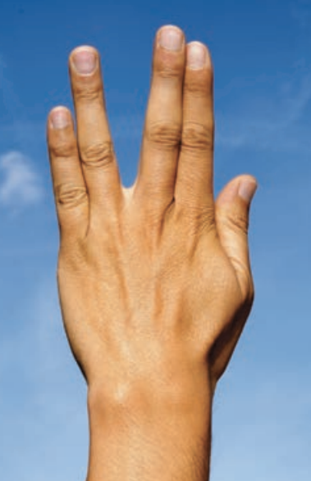  Image of Vulcan Greeting Data  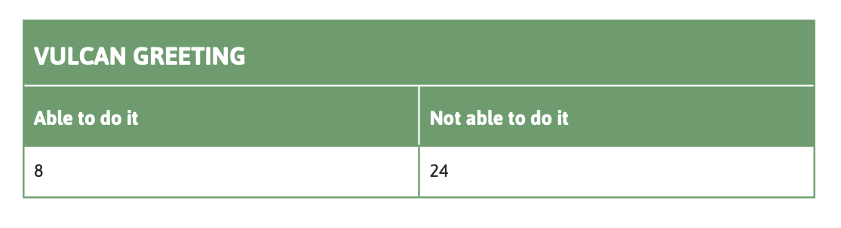  Either show Ss how to graph the data or instruct them to make a bar graph with the data. Or Share Graph  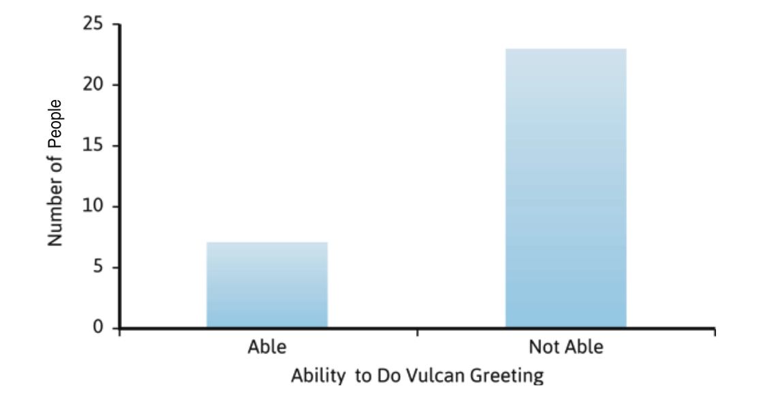  Share PI: Inherited Traits. If possible, collect Ss data on two traits from this lesson and two from the previous lesson. Have Ss graph the data and answer the Making Sense questions.  Key: Some human traits have only two variations, while other human traits have many variations. | SE Activity 1.2 | SE Activity 1.2  Print PIs/Images  Image: Vulcan Greeting  Image: Vulcan Greeting Data  PI: Inherited Traits
Activity 1.3  Baby, Where Did You Get Those Eyes? | If possible, ask the questions in the Synthesizing Discussion in the TE. Otherwise, teachers will want Ss to record these in Activity 1.3. Remind Ss what they learned in Life Science 2 and display PI: Human Cheek Cells. Review the nucleus as the control center of the cell and that molecules make up the cell structures.  Display PI: From Cells to DNA. Use this as a visual guide to the differences between cells, nucleus, chromosomes and DNA. Have Ss write questions they have and post them on the Driving Question Board.  Introduce the Driving Question Board (DQB): Throughout the unit, Ss record their own, original questions as they arise. See IQWST Overview for more information on how to use and manage the DQB.  Key: Cells are made of molecules that can be arranged in different ways. DNA is a molecule, so it is something physical. Compressed DNA in the cell is a chromosome. Every cell of the body that has a nucleus contains DNA. | SE Activity 1.3 | SE Activity 1.3  Print PIs  - Human Cheek Cells  - From Cell to DNA
Reading One | Where Did You Get Those Eyes?  Key: Ss obtain information about why scientists study genetics. | SE Reading One | SE Reading One

Lesson 2  (3 sessions) | What Traits Get Passed On? | Download Lesson 2 Teaching Slides
ACTIVITY | TEACHING RECOMMENDATIONS | DIGITAL RESOURCES | PRINT RESOURCES | MATERIALS  FOR EACH STUDENT
Activity 2.1  Are Traits Connected? | Ss will not be able to taste Brussel Sprouts unless they have access remotely, but teachers could poll Ss to see if they like them. A piece of PTC paper could be provided for Ss to do the test remotely, and the results for the class combined.  Ask Ss to make a prediction. In the absence of class data, teachers can share Image of Data related to Brussel Sprouts and PTC paper so that Ss see that there is a correlation between tasting Brussel sprouts and PTC paper.  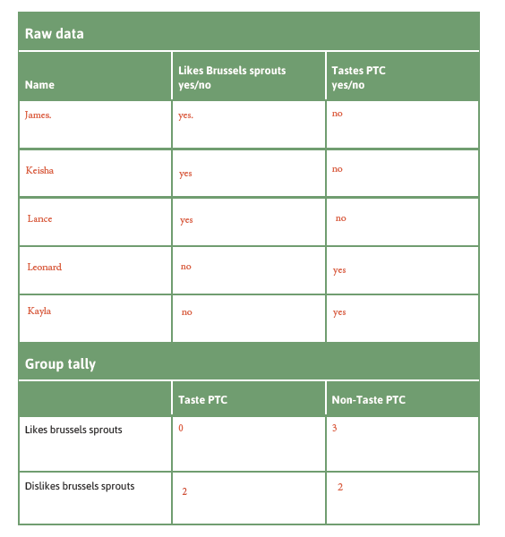  To see if there are correlations between other human traits, teachers could have Ss report whether or not they could roll their tongue. If teachers cannot collect the data from the class, They should see that there is not a correlation between tongue rolling and PTC tasting.  Have Ss answer the Making Sense questions.  Totals in Pedigrees for Tongue Rolling  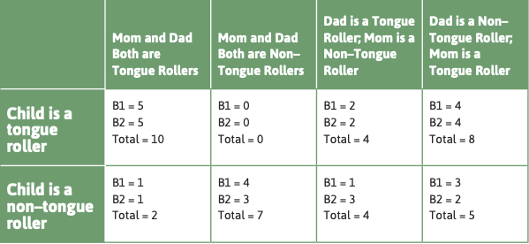  Totals in Pedigrees for PTC  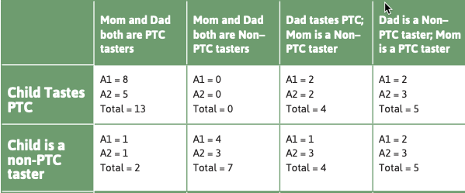  Key: Some traits have only two variations and there are correlations between some traits and not others. | SE Activity 2.1 | SE Activity 2.1  Print PI  Data Table for Comparing Two Traits  Image of Data related to Brussel Sprouts and PTC paper  Totals in Pedigrees for Tongue Rolling  Totals in Pedigrees for PTC | (3)pieces of PTC paper
Reading One | Do the Traits I Inherited Affect My Sense of Taste or Smell?  Key: This reading explains more about PTC tasting and how it was discovered as well as how smell and taste are connected. | SE Reading One | SE Reading One
Activity 2.2  How Do Plants Reproduce? | Ss will be unable to dissect a flower unless they have one remotely. Explain that you will be finding out how plants reproduce to help with figuring out how to model traits being passed on in living things. Share PI: Flower Parts and have Ss draw a diagram of the flower without the petals. Share the Activity Video Flower Dissection.. Discuss the male and female parts of the flower and have Ss complete the Making Sense questions.  Key: Both plants and humans reproduce sexually since they both have eggs and sperm. | SE Activity 2.2  Activity Video 2.2 Flower Dissection | SE Activity 2.2  PI: Flower Parts
Reading Two | What Is the Buzz About?  Key: This reading is about pollination of plants by bees and the impact the declining bee population has on plant reproduction. | SE Reading Two | SE Reading Two
Activity 2.3  Is There a Pattern to How Traits Get Passed On? | Share PI: Fast Plant picture. Explain that some plants have purple stems and some have non-purple stems and that we will be using these to look for patterns of how traits are passed on from one generation to the next. If possible, have a discussion with Ss about how to set up an investigation to see if the trait of stem color is inherited and if there is a pattern. There will be three parts to the investigation, crossing purple with purple, crossing non-purple with non-purple and crossing purple with non-purple.  Show the videos of Wisconsin Fast Plant germination and life cycle.  Have Ss make a prediction. They can see the picture in the procedure about how this investigation would be set up.  Key: Fast plants come in two variations: purple and non-purple. There are 3 combinations of variation that produce these plants. | SE Activity 2.3  Video: germination  Video: life cycle | SE Activity 2.3  Print PI  - Fast Plants

Lesson 3  (2 sessions) | Can We Determine Patterns in Traits? | Download Lesson 3 Teaching Slides
ACTIVITY | TEACHING RECOMMENDATIONS | DIGITAL RESOURCES | PRINT RESOURCES | MATERIALS  FOR EACH STUDENT
Activity 3.1  What Are the Patterns in How Traits Are Inherited? | Explain how pedigrees keep track of family relationships and traits. Teachers will want to make sure that Ss understand the symbols used and how it is put together. Share the simple pedigree of Ralph the dog from the TE and discuss the components of a pedigree. See TE for discussion prompts.  Have Ss fill in the prediction tables for both tongue rolling and PTC tasting.  If Ss do not have a way to share data, then you can have them complete Part 1 in the Procedure by assigning them Pedigree A1 and give them the data for the totals. These are the images below: Totals in Pedigrees for PTC and PI: Totals in Pedigrees for Tongue-Rolling.  Totals in Pedigrees for Tongue Rolling  Totals in Pedigrees for PTC  Have Ss answer the Making Sense questions.  If possible, have an online interactive Pattern and Evidence Chart as described in the TE.  Share these charts with Ss. They are found in both the print and IDE versions of LS3, but not in the TE. Ss use these charts to complete the data tables. Ss may be assigned an individual pedigree or all of them to complete  Key: There are patterns in how traits are passed from parents to offspring. Offspring can get instructions for a trait from either parent. Sometimes offspring inherit identical traits and sometimes they don’t. Offspring can show a variation of a trait that neither parent shows. Certain combinations of parents always have offspring that look like them. | SE Activity 2.1  Activity 2.1.Data Table #1 Data  Activity 2.1 Data table #2 Data | SE Activity 2.1  Print PI  Data Table for Comparing Two Traits  Image of Data related to Brussel Sprouts and PTC paper  Totals in Pedigrees for Tongue Rolling  Totals in Pedigrees for PTC  Activity 2.1 Data Table #1. #2
Activity 3.2  Are There Patterns in Plant Traits? | Ss will be unable to germinate the plants remotely. Teachers may explain how the data was generated and then share Image : Group Data for Purple x Purple, Non-purple x Non-purple, Purple x Non-purple. Have Ss record the data, telling them that they will record the F₂ generation in Lesson 4.  .  Relate the data to the Patterns and Evidence chart.  Have Ss answer the Making Sense questions 1-4. (They will answer #5 in the next activity and #s 6-9 during Lesson 4).  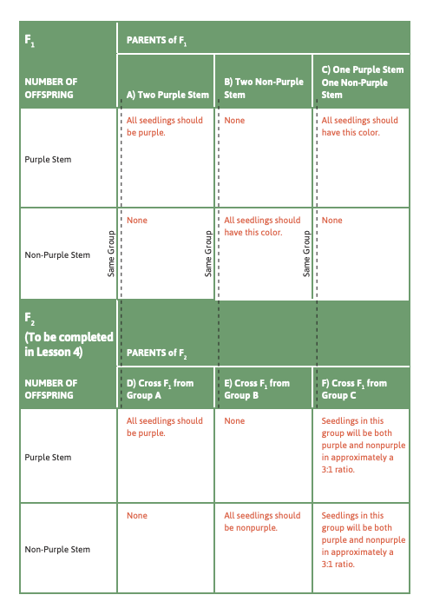  Key: Non-purple offspring only came from non-purple × non-purple crosses. Purple offspring came from both purple × purple crosses and purple × non-purple crosses. | SE Activity 3.2  Group Data for Purple x Purple,  Group Data for Purple x Non-Purple  Group Data for Non-Purple x Non-Purple | SE Activity 3.2  Copies of Group Data for Purple x Purple, Non-purple x Non-purple,  Purple x Non-purple
Activity 3.3  What Seed Patterns Are There in a Future Generation? | If possible, have a discussion about how the human data compared to the plant data. Tell Ss that they will now see what happens when you grow plants in the F₁ generation and then take their seeds and germinate them. Direct Ss to fill in the “F₂ Generation Predictions” section on the last page of SE Activity 3.2. Have Ss complete the prediction for the F₂ offspring. Have them answer Making Sense question #5 from Activity 3.2.  Key: Offspring can inherit traits from either parent.  Key: Different offspring of the same two parents can inherit different traits from each parent.  Key: For some traits, when parents have the same trait, the offspring always have the same trait as the parents. | SE Activity 3.3 | SE Activity 3.3
Reading One | Heredity Patterns— A Key to Diagnosis  Key: In this reading, Ss look at practical ways understanding inherited trait patterns could be helpful. Sickle Cell Anemia and Genetic Counseling are discussed. | SE Reading One | SE Reading One
Checkpoint: The final question of Lesson 3 Reading One can be used to assess Ss ability to explain patterns in data about inherited traits.

Lesson 4  (2 sessions) | Do Traits Show Patterns over Multiple Generations? | Download Lesson 4 Teaching Slides
ACTIVITY | TEACHING RECOMMENDATIONS | DIGITAL RESOURCES | PRINT RESOURCES | MATERIALS  FOR EACH STUDENT
Activity 4.1  How Do Traits Get Passed On? | Share PI: Predictions of Variation in Human Traits. Have Ss make predictions and record their ideas if possible. They will then look at pedigrees for more than two generations.  Ss work to complete the “Case family observation data” table in their SE by looking carefully at the pedigrees.  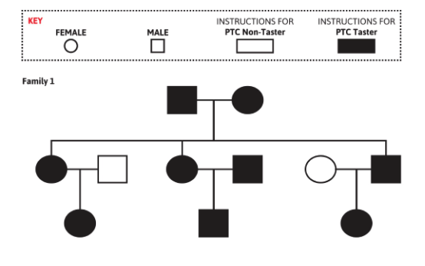  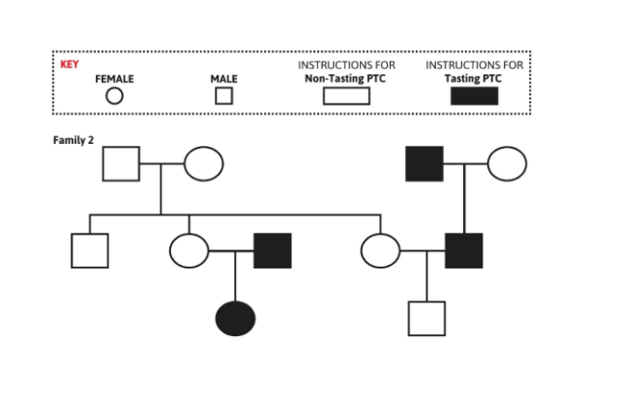  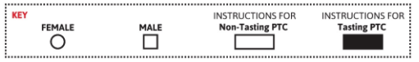  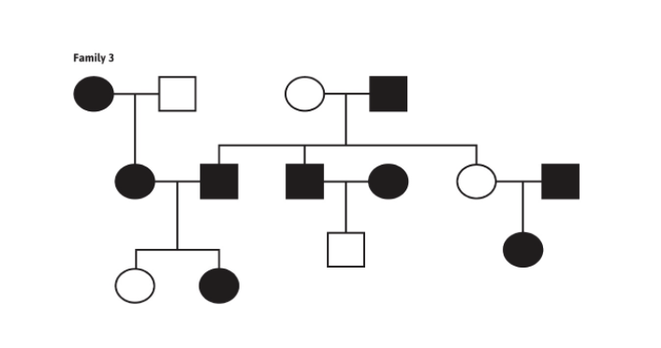  They should then analyze their data by answering the Making Sense questions.  Teachers may also want to share a complete Ss answer sheet after the activity and discuss. Teachers may also want to share the completed Pattern and Evidence Chart at the end of Lesson 4 at this time and discuss.  Key: Sometimes PTC-taster parents produce PTC non-taster offspring, while other families with both PTC-taster parents do not have PTC non-taster offspring. This is evidence that PTC-Tasters that have PTC non-taster offspring may not have the same instructions as PTC-tasters who have only PTC-tasters as ancestors. | SE Activity 4.1  PI:  Predictions of Variation in Human Traits  Pedigree Data Tables from Family 1 - 3 | SE Activity 4.1  Print PI:  Predictions of Variation in Human Traits  Pedigree Data Tables from Family 1 - 3
Activity 4.2  What about the Next Generation of Seeds? | This activity allows Ss to look at data from a third generation of plants. Remind them of the new ideas from the last activity that not all PTC-tasters seem to have the same information to pass on and that sometimes traits are seen in the first generation, are not seen in the second and then seen again in the third.  Ss will not have been able to do the activity of germinating the third generation, so teachers will need to share the data with them. Share Image of : Class Seedling Data Activity 4.2  Ss should use this data to complete the pedigrees. If possible, have a Synthesizing discussion.  Key: Sometimes Purple stem plants only give purple stem offspring and sometimes two purple stem plants give some purple and some non-purple offspring. All of the purple plants may not have the same set of instructions. Non-purple x non-purple always gives non-purple. | SE Activity 4.2  Class Seedling Data Activity 4.2 | SE Activity 4.2  Class Seedling Data Activity 4.2 Image
Activity 4.3  Synthesizing the Data | If possible, have a synthesize discussion with Ss about inheritance in both plants and humans and identify them as patterns based on the evidence collected. Fill in the Patterns and Evidence Chart for Evidence from Plants.  Key: Organisms can somehow carry instructions about a trait from their parents that can be passed to their offspring, even if they are not using the instructions to show the trait. | SE Activity 4.3 | SE Activity 4.3
Reading One | Why Are Patterns Important?  Key: The reading focuses on the work of Gregor Mendel and how he used his observations about patterns to develop a model of inheritance. | SE Reading One | SE Reading One

Lesson 5  (2 sessions) | How Do Instructions from Our Parents Get inside Us? | Download Lesson 5 Teaching Slides
ACTIVITY | TEACHING RECOMMENDATIONS | DIGITAL RESOURCES | PRINT RESOURCES | MATERIALS  FOR EACH STUDENT
Activity 5.1  How Do I Get New Cells? | Share PI: From Cell to DNA, reviewing and pointing to the single strands of DNA in the nucleus that are called chromosomes. Share PI: Karyotypes to illustrate how scientists look at chromosomes to make them easier to compare and analyze. Have them find some patterns like they come in pairs.  Ss may want to take notes during discussion if you are able to conduct a virtual session. Otherwise use discussion prompts for Ss note taking.  If possible, review the key ideas about plant reproduction from Lesson 2 as outlined in the TE.  Share PI: Mitosis. Review mitosis with Ss from what they learned in Module 1. Share PI: Mitosis/meiosis. Compare mitosis with mitosis.  Share PI: Karyotypes and point out the bands on chromosomes 1, 9 and 16. Share PI: Gene to zoom in on chromosomes. The pink section represents a gene.  Tell Ss that a gene in plants carries the instructions for producing anthocyanin which produces a purple color in plants.  Display PI: Gene for Stem Color and explain that they are looking at a representation of a chromosome. A gene for a specific trait appears at the same place on both copies of the chromosome. The band represents the gene, the color represents the allele, the variation of the trait.  Relate this to the example in plants.  Key: Each allele is a version of the gene that carries the instructions for a chemical resulting in a variation of a particular trait. Offspring receive two alleles, one from each parent. | SE Activity 5.1  PIs  - From Cell to DNA  - Karyotypes  - Cell Division  - Sperm and Egg Cells (optional)  - Gene  - Gene for Stem Color  - Mitosis and Meiosis | SE Activity 5.1  Print PIs  - From Cell to DNA  - Karyotypes  - Cell Division  - Sperm and Egg Cells (optional)  - Gene  - Gene for Stem Color  - Mitosis and Meiosis
Activity 5.2  How Can Parents Produce Offspring with Different Traits? | Explain that the word gamete means a sex cell, egg and sperm. Ss will do the procedure and find the additional combinations that are possible with the three chromosome pairs of a yllis. There are eight total possible combinations. Have Ss figure out how many combinations there are with 5, 6, 8 and 10 chromosome pairs and let them know that humans have 23 pairs. Ss should answer the Making Sense questions.  Teachers may want to share the completed Ss activity and discuss.  Key: Offspring have two copies (alleles) of the gene for a trait, one from each parent.  Key: During meiosis, a number of different combinations of the gametes will be produced.  Key: Each time a different egg from the same mother is fertilized by a sperm from the same father, different combinations of traits are likely to be in the egg and sperm. | SE Activity 5.2 | SE Activity 5.2
Reading One | Discovering the Source  Key: A unique occurrence in the genetics of one family, fraternal twins, causes scientists to ask new questions about their ideas. Ss see how scientists’ work always builds on the work of the scientists who have come before them. | SE Reading One | SE Reading One
Checkpoint: The question at the end of Lesson 5 Reading One can be used to assess Ss understanding of inherited traits and the role of genes in passing those traits on to offspring.

Learning Set 2:
Lesson 6  (2 sessions) | Constructing a Model of Inheritance | Download Lesson 6 Teaching Slides
ACTIVITY | TEACHING RECOMMENDATIONS | DIGITAL RESOURCES | PRINT RESOURCES | MATERIALS  FOR EACH STUDENT
Activity 6.1 | Remind Ss that they are trying to understand how two plants that appear purple on the outside can have an offspring that is non-purple. Review the ideas about instructions for traits from Lesson 5 as outlined in the TE. Explain the terms genotype and phenotype.  Ss will be developing a model to explain how the genetic instructions for traits are passed from parents to offspring. Teachers may want to review how Ss developed a model to explain how water cycles through Earth’s systems in Module 6.2.  If possible, have a discussion with Ss about how to develop a model of inheritance as described in the TE. Ss need to know that only two alleles can be passed from parent to offspring. The combinations of alleles for purple and non-purple produce the phenotypes that are observed in the seedlings. Be sure to distinguish between how we are representing phenotype (descriptive words written out such as purple, non-purple) and genotypes that will be represented by one- or two-letter abbreviations (p=purple and np=non-purple.)  Share PI: Gene for Stem Color and review what they know and what they are trying to find out. Share PI: Genotype/Phenotype. Ss should write the possible genotypes in the chart in their SE. For the phenotypes, they should have p/p=Purple, np/np=non-purple and np/p could be purple or non-purple. Have Ss answer the Making Sense questions.  Ss will be figuring out in the next lesson whether np/p results in a purple or non-purple phenotype.  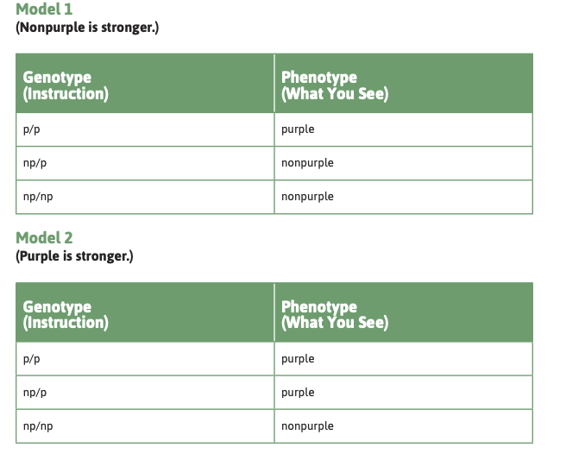Possible Models  Key: Ss have 2 rules for their model: Rule 1: p/p always results in a purple phenotype. Rule 2: np/np always results in a non-purple phenotype.  np/p is a rule that needs to be figured out. | SE Activity 6.1 | SE Activity 6.1  Image of Possible Models  PI: Class Seedling Data Activity 4.2  PI: Gene for Stem Color  PI: Genotype/Phenotype
Activity 6.2  Testing the Model | Use Image of Possible Models and remind Ss of the rules of the model they decided and what they still have to figure out. There are eight pedigrees that correspond to the seed groups. Ss test the models against all the data in PI: Class Seedling Data Activity 4.2. For each individual in the pedigree, Ss will fill in the genotype for both the body cell and the sex cell. They are trying to explain the data they collected for the F₂ generation of seedlings, where they saw two purple F₁ generation parents produce non-purple offspring.  If possible, work through the first pedigree with them as described in the TE. Ss should complete each pedigree with the referenced Model and tell whether the model accounts for the data and if not, where it fails and why.  There are detailed instructions in the TE for how to test these models and how to guide Ss to test the models with the pedigrees.  Possible Models  Key: Model 2 explains that both the p/np and p/p produce purple phenotypes. If two purples that are p/np are crossed, then an np allele from each parent can combine to give offspring that are non-purple. | SE Activity 6.2 | SE Activity 6.2  Print PIs/Images  Image of Possible Models  PI: Class Seedling Data Activity 4.2  - Gene for Stem Color  - Genotype/Phenotype
Reading One | Using Models to Decide between Possible Explanations  Key: This reading is about how scientists discovered the structure of DNA. Rosalind Franklin, Francis Crick and James Watson studied things too small to be seen even with a microscope and used models to help them with their work. | SE Reading One | SE Reading One
Checkpoint: Question 17 of Activity 6.2 can be used as an assessment. It asks them to write an evidence-based explanation of their model.

Lesson 7  (2 sessions) | Extending and Applying the Model of Inheritance | Download Lesson 7 Teaching Slides
ACTIVITY | TEACHING RECOMMENDATIONS | DIGITAL RESOURCES | PRINT RESOURCES | MATERIALS  FOR EACH STUDENT
Activity 7.1  Extending and Applying the Model of Inheritance | Connect the Model used with plants to PTC tasting in humans. If possible, discuss with Ss about how to figure out which genotype goes with which phenotype for PTC tasting. Share PI: Model Chart and have Ss fill in the chart for PTC in the SE. They should do this according to Model 2 from Activity 6.2.  Share PI: Predictions of Variations in Human Traits from Lesson 4. Relate what they learned about pedigrees to what they know now about the instructions that determine body traits and the genotypes and phenotypes.  Teachers may divide the class into half with half working on Pedigree 1 and the other half working on Pedigree 2 and then have them share. Or teachers could assign one pedigree for one day and one for the next day, having all Ss do both pedigrees. Share PI: Sample Pedigree from SE Activity 7.1. Teachers may need to work through an example from the TE before Ss start their work.  If possible, have a Pressing for Understanding discussion after Ss finish and introduce the idea of dominant and recessive alleles. Relate this to PTC tasting and to Tongue rolling.  Key: Human data for PTC and Tongue rolling follows the same pattern as that in plant stem color where some alleles appear to be dominant over others. | SE Activity 7.1 | SE Activity 7.1  Print PIs  - Predictions of Variations in Human Trait  - Model Chart (from Lesson 6)  - Sample Pedigree 1  - Sample Pedigree 2
Activity 7.2  Albinism | Ss should know now that some alleles appear to be dominant over others, but do not know how this happens. You should share some information about albinism from the TE with Ss at this point. Share PI: Model Chart (from Lesson 6) and have Ss fill in the table with the possible combinations of alleles for albinism. Tell Ss that a capital letter indicates the dominant trait and a small letter indicates the recessive. (This replaces the p and np that was previously used.)  Share PI: Picture of Brother and Sister and ask Ss what alleles they think the boy has if neither of his parents shows the albinism trait.  Review the ideas in the TE to stress the point that the parents need to have Aa for their son to have aa.  Have Ss fill out the chart in the SE with the possible genotypes and phenotypes for albinism. They should then answer the Making Sense questions. Teachers may want to use the discussion prompts and provide the completed Genotype/Phenotype table in the TE.  Key: Some alleles are dominant and some can be recessive. If the alleles are not the same, the instructions of the dominant allele show up in the phenotype. | SE Activity 7.2 | SE Activity 7.2  Print  PI: Picture of Brother and Sister  PI: Model Chart
Reading One | Reading One: Which Instructions Get Followed?  Key: Ss will learn about the genetic connection to cholesterol and build on their understanding of dominant and recessive alleles by learning about sickle cell disease. | SE Reading One | SE Reading One
Checkpoint: The explanations in SE Activity 7.2 is a good opportunity to assess Ss understanding of inheritance patterns and how Ss support their ideas with data.

Learning Set 3: Why Does Variation Matter?
Lesson 8  (3 sessions) | Variations, Variations, and More Variations | Download Lesson 8 Teaching Slides
ACTIVITY | TEACHING RECOMMENDATIONS | DIGITAL RESOURCES | PRINT RESOURCES | MATERIALS  FOR EACH STUDENT
Activity 8.1  What Do I Do with All This Data? | Share PI: Line of People. Use the picture to think about traits that have more than one variation such as height, weight and hair color.  Share Image of Types of Graphs and review the different types. Have a discussion of different types of graphs. Teachers may want to provide examples of different types of graphs as presented in the TE and lead a discussion regarding types and uses for different graphs. Teachers may want to have slides of the graph review cards to share with Ss.  Image of Types of Graphs  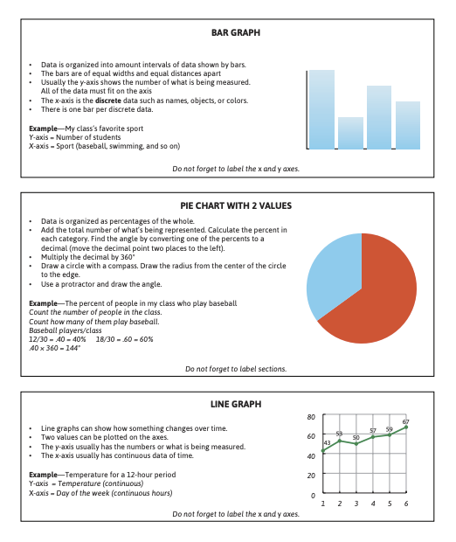  If possible, have Ss measure themselves in centimeters remotely and collect data online, dividing the class into groups of four or five. Then have them join another group. Otherwise, use the data in use the data from Lincoln Middle School Data included below  Have Ss look at the table in the SE titled “Graph”. Ss should choose one of the representation types to use with the data. If possible, have Ss share their graphs to see how they compare. Have a discussion about representing large amounts of data with histograms.  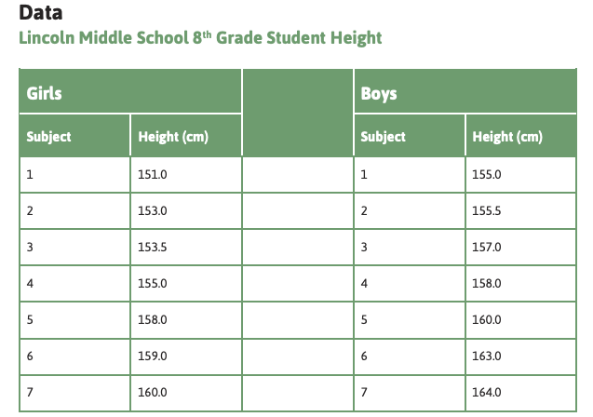  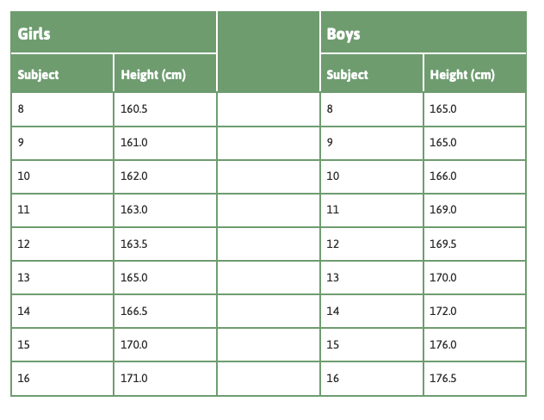  Key: Unlike what Ss saw in the human traits in Lesson 2, height has more than two variations. | SE Activity 8.1 | SE Activity 8.1  PI: Line of People  Image of Types of Graphs  Image of Data table form Lincoln Middle School
Activity 8.2  How Can We Show Ranges of Variation? | If possible, have Ss measure height and make a digital histogram with their height and whether they are male or female. Otherwise, have Ss make the histogram in their SE using the sample data in the Lincoln Middle School Data. Alternatively, teachers may want to provide their own examples of a class histogram and discuss rather than Ss trying to construct from a provided data table or focus on using only the Lincoln Middle School 8th Grade Height data to discuss histograms and answer making sense questions.  A discussion of histograms is important as outlined in the TE.  Share PI: Living Histogram. Have Ss compare this to their class histogram.  Have Ss make a prediction and then analyze the height data for 8th graders from Lincoln Middle School in SE Activity 8.2. Ss should answer the Making Sense questions.  Key: A histogram is used for continuous data such as height or weight. The bars must represent the same range of data (bin). | SE Activity 8.2 | SE Activity 8.2  Print PIs  - Line of People  - Living Histogram  PI: Height Data
Activity 8.3  Variation Everywhere, So What? | Share Monarch Butterfly Larvae. Ask Ss to share traits and variations of traits that they see in the picture.  Part 1:  Ss will look at each organism and write four traits and their variations. If Ss do not have access to colored pictures, teachers may want to share PI: Snails, PI: Guppies and PI: Orchids. Organisms have multiple traits and multiple variations of those traits, so scientists observe large populations of organisms to understand their frequency. Ss should answer the Making Sense questions.  Part 2:  Ss should then do part 2, analyzing graphs of data that represent variations of traits in populations. If Ss do not have access to colored pictures, you may want to share PI: Blood Type Graph. If possible, have a discussion to compare the representations of data.  Key: Scientists gather information and organize it in ways that can help them draw conclusions, use data to see whether something has changed in a population, and do not always represent data in the exact same way. | SE Activity 8.3 | SE Activity 8.3  Print PIs  - Monarch Butterfly Larvae  - Snails:  - Guppies  - Orchids  - Blood Type Graph
Activity 8.4  How Do Genes Work for Continuous Traits? | Explain that Ss will be exploring what happens to a trait when there are multiple variations. They will test a simple model. Share PI: Height and Growth Genes. Have Ss complete Activity 8.4 in their SE.  Key: Some traits have a continuous range of variations (e.g., height, eye color, skin color). (Added to Scientific Principle #1 from Lesson 2). | SE Activity 8.4 | SE Activity 8.4
Reading One | Height— Unraveling a Genetic Puzzle  Key: This reading contains additional information about twins to provide Ss with an example of scientists pursuing questions out of observation and interest. | SE Reading One | SE Reading One
Checkpoint: The final “Making Sense question in SE Activity 8.3 can be used to assess Ss’ ability to analyze data to describe trait variations in a population. At the end of this Learning Set, teachers may choose to assess learning by having Ss write an explanation that answers the Learning Set question: How Does the Inside Affect the Outside? This should require a CER-formatted explanation.

Lesson 9  (3 sessions) | Do Variations between Individuals Matter? | Download Lesson 9 Teaching Slides
ACTIVITY | TEACHING RECOMMENDATIONS | DIGITAL RESOURCES | PRINT RESOURCES | MATERIALS  FOR EACH STUDENT
Activity 9.1  The Case of the Peppered Moth | Discuss advantages of both tall and short height in the animal kingdom and what makes a particular height an advantage or a disadvantage.  Share PI: Peppered Moth, Carbonaria Variation and PI: Peppered Moth, Typica Variation (Hidden), PI: Peppered Moth, Typica Variation (Visible) and PI: Peppered Moth, Comparison Picture. Tell Ss that these are the same species of moth taken from the same location. Have Ss find variations.  Have Ss read the information in the SE on the peppered moths and answer the Making Sense questions. If possible discuss various hypotheses for what is causing the change in the moth population. You may want to relate it to their investigation of lamprey in the Great Lakes in 7th grade.  Key: Environmental changes can have a direct effect on organisms in a population. | SE Activity 9.1 | SE Activity 9.1  PI: Peppered Moth, Carbonaria Variation  PI: Peppered Moth, Typica Variation (Hidden)  PI: Peppered Moth, Typica Variation (Visible)  PI: Peppered Moth, Comparison Picture
Activity 9.2  How Does Variation Matter? | Teachers can divide the class into groups of four and have Ss each read one of the pieces of evidence. They should fill out the chart for their piece of evidence and then share with the others. The teacher can alternately assign one of the pieces of evidence to all the Ss and then share the others with them or assign all four pieces of evidence to all Ss. Ss can then answer the Making Sense questions.  At the end of the activity, Ss are asked to construct a cause-and-effect chain using the evidence from the studies they investigated. If possible, have Ss share their ideas.  Key: Scientists use many methods to collect information about population changes over time. Survival of organisms with a particular trait variation may be favored in a particular environment. | SE Activity 9.2 | SE Activity 9.2
Reading One | How Does Variation Matter?  Key: Ss will read about variations in a clover species and how those variations affect the ability of the variants to survive in different geographical areas. | SE Reading One | SE Reading One
Activity 9.3  Explaining the Change in the Peppered Moth Population | Ss will write a Scientific Explanation in the CER format to explain why the population of peppered moths changed over time. If possible, have them do this in a group first and then have the class synthesize ideas into a consensus explanation.  Key: Changes in a population can occur when a population of organisms varies in an inherited trait and there is a change in the environment that affects the organism’s survival.  Key: If one variation of the trait has an advantage for survival in a particular environment, individuals with that variation are more likely to survive and reproduce, so the proportion of individuals with that variation increases in the next generations. | SE Activity 9.3 | SE Activity 9.3
Checkpoint: Ss’ explanation from Activity 9.3 provides an opportunity to assess how well they understand the relationship among variation, environment, and population change.

Lesson 10  (1-5 sessions) | The Finch Investigation - Optional if internet is available | Download Lesson 10 Teaching Slides
ACTIVITY | TEACHING RECOMMENDATIONS | DIGITAL RESOURCES | PRINT RESOURCES | MATERIALS  FOR EACH STUDENT
Activity 10.1  Background to the Mystery | This activity as well as 10.2-10.5 requires internet access and may not be feasible for some Ss. All that is needed for these activities is an Internet browser such as Safari or Firefox. Nothing needs to be installed on the computers Ss will use.  The website can be found at http://bguile.northwestern.edu  Review how the moth population changed over time.  Project the Introduction section of the BGuILE software and tell the Ss what is outlined in the TE.  Ss will go to “Explore Ecosystem” in the program and click on the Finch button. Have Ss identify any traits they see and identify factors that might have affected the finch population. They should put those in the left column in a chart in the SE. They should then fill in the chart with information from the program. If possible, have a class discussion to share information.  Ss can then choose a problem that they will investigate from those that were introduced in the software. If possible, do this in pairs, but Ss could do it individually. You may want to have a list of problems for them to investigate if they have problems figuring out one on their own.  Key: Ss will become familiar with the ecosystem of the Galapagos Islands and especially Daphne Major, including the seasonal changes in temperature and rainfall, the animals and plants that are native to the island, and the food sources, behavior and reproductive cycles of the animals there. They will choose a problem to investigate. | SE Activity 10.1 | SE Activity 10.1
Activity 3.2  Data Comparisons and Individual Data | Guide Ss through the steps to make a comparison of traits by demonstrating it using the software, following the example in the TE. Relate what they are about to do to the moth problem in Lesson 2.  Have Ss find the difference between the two graphs.  Show Ss how to save their data including notes and graphs.  Tell Ss that they are trying to answer the following questions:  Why did the birds die on Daphne Major? (What changed and how did it change?)  How were some birds able to survive? (Did variation matter?)  Key: Ss become familiar with the types of data in the database, and how to compare sets of data using the software to answer the investigation questions.
Activity 3.3  Investigating the Finches | Ss will use the software to find data to answer the focus questions. They will record their data in the program and fill in the charts in the SE. Ss may have difficulty with this since it is open-ended, so teachers may want to have time to answer individual questions. They should have a possible claim backed by evidence at the end of this activity.  Key: Ss will have developed an idea about why they think some finches on the island died, and why those that didn’t die were able to survive. They will have collected data that they think supports their claims to answer those questions.
Reading One | Where Did the Data Come From?  Key: Ss have been introduced to software that contains a great deal of data. This reading gives background information on how those data were collected by Peter and Rosemary Grant in the decades that they collected and analyzed data. | SE Reading One | SE Reading One
Activity 3.4  Midpoint Sharing | Each group or individual should synthesize the ideas they have so far and formulate a complete explanation for the two questions: Why are the finches dying, and why are some able to survive? If possible, have two groups share explanations and evaluate it. They should then discuss their evaluations of each other’s explanations. These groups should work together for the rest of Lesson 3 if possible.  Complete the Making Sense questions as well as the Follow-Up.  Key: Ss will write a preliminary explanation about why they think some finches on the island died, and why those that didn’t die were able to survive. They will use data collected that they think supports their claims to answer those questions and share it with others.
Activity 3.5  Explaining the Mystery | Ss (individually or as groups of four) should write an evidence-based explanation for the questions of why the finches died and why some finches were able to survive.  If possible, have Ss share their explanations with the class and then have a Pressing for Understanding discussion.  Key: The finches with longer beaks had a better chance at surviving than those with shorter beaks. There was a drought and so there were fewer plants, less seeds and less food for finches. The seeds that were left were the large seeds which the longer beaks had a better chance of cracking. Those finches with short beaks couldn’t crack open large seeds, so they died. So a larger percentage of finches with long beaks survived.
Checkpoint: Have Ss write scientific explanations individually to answer each of the questions. This would allow you to assess their ability to organize data that supports a claim and articulate a chain of reasoning that answers a complex question.

Lesson 11  (2 sessions) | Constructing a General Model of Population Change | Download Lesson 11 Teaching Slides
ACTIVITY | TEACHING RECOMMENDATIONS | DIGITAL RESOURCES | PRINT RESOURCES | MATERIALS  FOR EACH STUDENT
Activity 11.1  Constructing a General Model of How Populations Can Change | Tell Ss that they will be identifying what is common between the moth and finch explanations and will try and make their model more general so that it applies to other situations. Ss can work on this in pairs or groups if possible or individually. Teachers may want to work through the Peppered Moth explanation with them first.  If possible, develop a class consensus model, or share the completed consensus model for discussion purposes using the answers in the TE for both Part 1 and 2.  Share PI: Consensus Model of Population Change. Teachers may want to have some general criteria such as Generality and enough detail to explain Cause and Effect.  Key: Ss will understand that there can be a common set of scientific rules that govern the way changes in populations happen over multiple populations.  If one variation of the trait has an advantage for survival in a particular environment, individuals with that variation are more likely to survive and reproduce, so the proportion of individuals with that variation increases in the next generations. | SE Activity 11.1 | SE Activity 11.1  PI: Consensus Model of Population Change
Reading One | Does Selection Always Occur Naturally?  Key: Ss obtain information about how selective breeding has changed the food we eat today. | SE Reading One | SE Reading One
Activity 11.2  Does the Consensus Model Work? | Show/share PI: Consensus Model of Population completed with the class’s consensus model. Tell Ss that they will now use this model with other populations to see if it works. They should copy it into the first column in their SE.  If possible, divide into groups and assign some groups antibiotic-resistant bacteria and the other groups DDT-resistant insects. Teachers could also have Ss work in pairs or individually. They will read the fact sheet about their population and see whether it fits with the consensus model. They could do both organisms if they are unable to share their ideas or just focus on one organism.  Have Ss answer the Making Sense questions.  Teachers may want to share the completed Activity 11.2 student sheet and discuss with Ss.  Key: Their model of population changes applies to populations representing widely different types of organisms, environments and environmental changes such as antibiotic-resistant bacteria and DDT-resistant insects. | SE Activity 11.2 | SE Activity 11.2
Activity 11.3  Putting It All Together-Why Do Organisms Look the Way They Do? | Review the main types of influences on organisms that they have investigated during the unit. If possible, have Ss give examples from the unit of organisms that have been affected by each influence.  Use the discussion prompts in the TE and relate to the DQB.  Key: Organisms look the way they do because of a combination of:  - Species differences  - Inheritance of individual differences  - Environmental influences on individuals  - Both inherited and environmental influences on the individual  - Environmental influences on populations. | SE Activity 11.3 | SE Activity 11.3  PI: Trout and Lamprey and Plants

Appendix 1  (1 session) | Evidence of Evolution | Download Appendix 1 Teaching Slides
ACTIVITY | TEACHING RECOMMENDATIONS | DIGITAL RESOURCES | PRINT RESOURCES | MATERIALS  FOR EACH STUDENT
Activity 1.1  Fossil Evidence | Tell Ss that paleontologists look at the shape of the bones they find, as well as the bones of living organisms, to help determine how an organism that no longer exists probably moved. Scientists also look at bone shapes and other features of the fossils to determine who the organism’s relatives were. Organisms with similar features are thought to be relatives.  Share PI: Pakicetus Skull and ask Ss what they observe.  Share PI: Pakicetus Skull and Skeleton. Ask Ss what they can tell from the picture on the right?  You could have a chart for Ss where they compare the five organisms in their SE or have Ss construct it themselves. (See Making Sense question #1 for examples of what to include in the chart). They should then fill in the chart and answer the Making Sense questions.  Key: From comparing the fossil evidence from five organisms that are now extinct to modern whales, we can see that whale’s early ancestors walked on land. |  | PI: Pakicetus Skull  PI: Pakicetus Skull and Skeleton  PI: Pakicetus and Ambulocetus Skeletons  PI: Artist Reconstructions of Pakicetus and Ambulocetus  PI: Whale Ancestry
Reading One | How Do Scientists Know What They Know about Evolution?  Key: Ss will read more about evidence for evolution in this lesson including transitional fossils. In the reading, Ss will learn how scientists determined the relatively close relationship between hippopotamuses and whales. | SE Reading One | SE Reading One
Activity 1.2  Similarities in Body Structures | Explain homologous structures using the crosscutting concept of structure and function.  Share PI: Model #1. Have Ss use the modeling clay to model the structure if possible. If not, have them color in the bones with five different colors.  Share PI: Model #2. If Ss have clay, have them use the same pieces that they did for Model #1, but change the shapes to match the newly projected image. Have Ss compare the two. They should then finish the rest of the Procedure. Teachers may identify the organisms for them. Have them fill in the Data and answer the Making Sense questions.  Key: There are structural similarities between many different modern organisms. Structural similarities may indicate common ancestry. | SE Activity 1.2 | SE Activity 1.2  PI: Model #1 (bones in a human hand and arm)  PI: Model #2 (bones in a whale flipper) | Modeling clay in five colors  Colored pencils in the same five colors
Activity 1.3  Evidence from Embryological Development | Let Ss know that they will be looking at the stages of development of six different vertebrates. Share PI: Parts of an Embryo so that they know what the different structures are. Then share PI: Adult Body Types. Let Ss know that the notochord becomes the spinal cord in adult vertebrates.  Have Ss look at the Embryo Stages cards of the six different organisms and tell them to put them in order with the early stages at the top of the chart and the later stages at the bottom. Share PI: Embryo Stages and have Ss check their order with the real order. They should then answer the Making Sense questions.  Key: Among different organisms, anatomical similarities in structure indicate a common ancestor. | SE Activity 1.3 | SE Activity 1.3  PI: Parts of an Embryo  PI: Adult Body Types  PI: Embryo Stages | Embryo Stages Deck Cards

Appendix 2  (1 session) | Evidence of Evolution | Download Appendix 2 Teaching Slides
ACTIVITY | TEACHING RECOMMENDATIONS | DIGITAL RESOURCES | PRINT RESOURCES | MATERIALS  FOR EACH STUDENT
Activity 2.1  Mechanism of Natural Selection | This activity cannot be done remotely.  Key: Animals that blend in the most are least likely to be captured. If there is variation in the population, then the ones with the best camouflage blend in and are able to survive and reproduce. They pass on their genes to the next generation. If the habitat changes then the ones that now blend in more are more likely to survive, reproduce and pass their genes on. The population will change so that more are the color that blends in. | SE Activity 2.1 | SE Activity 2.1
Activity 2.2  Adaptations-Changes in Traits over Time | This activity cannot be done remotely  Key: A mutation that leads to an adaptation that is beneficial for fitness, like a longer beak that improves the ability of an individual to find food, may become common in the population as more of those individuals with the adaptation survive and reproduce over time. | SE Activity 2.2 | SE Activity 2.2
Reading One | Darwin’s Theory of Evolution by Natural Selection  Key: This reading highlights Charles Darwin’s story coming up with the process of natural selection based on evidence he had seen. Alfred Wallace’s contribution is also discussed. | SE Reading One | SE Reading One
Activity 2.3  Artificial Selection | Ss should read SE Reading One. Ask them to think about natural selection compared to artificial selection and then discuss these.  Discuss any experience Ss have with animal or plant breeding.  Share PI: Wild and Domestic Chickens and discuss similarities and differences and selection when trying to develop a new breed of chicken.  Share PI: Chicken Trait Variations and discuss the purpose of the comb.  Share PI: Chicken Eggs and discuss this trait as one that is selected for.  Ss should read the Procedure, follow it and then answer the Making Sense questions.  Key: Artificial selection methods can be used to obtain organisms with particularly desirable or favored traits. Natural selection and artificial selection differ in the reasons why certain traits allow for a survival advantage. Natural selection confers advantage based on interactions with the environment. Artificial selection confers advantage based on human preferences. | SE Activity 2.3 | SE Activity 2.3  PI: Wild and Domestic Chickens  PI: Chicken Trait Variations  PI: Chicken Eggs | (1)Coin

Appendix 3  (1 session) | Evidence of Evolution | Download Appendix 3 Teaching Slides
ACTIVITY | TEACHING RECOMMENDATIONS | DIGITAL RESOURCES | PRINT RESOURCES | MATERIALS  FOR EACH STUDENT
Activity 3.1  Evaluating the Use of GMOs | Discuss or review the types of traits that living things can inherit from their parents. Relate to DNA. Make sure Ss know that two different species cannot crossbred (except in rare circumstances).  Explain GMOs and have Ss share their ideas about them.  Ss should follow the Procedure for the Design Problem and do the trade-off analysis. They may need help figuring out how to do this. They should then answer the Making Sense questions.  Key: Genetically-modified organisms are artificially selected from a population that is engineered by humans to have certain trait variations. This kind of genetic engineering is used to solve human problems, and may have advantages or disadvantages for human society. | SE Activity 3.1 | SE Activity 3.1
Reading One | How Are GMOs Useful?  Key: This reading introduces the idea of genetically-modified organisms. | SE Reading One | SE Reading One

SUMMATIVE ASSESSMENT: Ss should be able to write a scientific explanation for the Driving Question: Why Do Organisms Look the Way They Do? Ss might create a poster or storyboard regarding a trait. For each trait, Ss could indicate which of the four concepts influenced the trait— is this a species characteristic? Environmental influence on individuals? Hereditary trait? Both heredity and environment? Environmental influence on the population? Ss might choose to answer a simple question such as “Why do I look more like my cousin than my sister?”
They could also include environmental influences on populations as evidenced by natural selection.

Teachers might choose to emphasize only a portion of this as a final assessment, given what they are able to teach and what Ss are actually able to do during this remotely taught unit.

