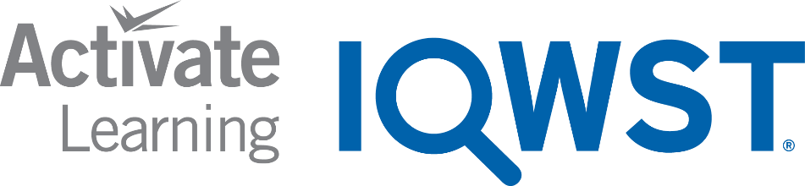
REMOTE LEARNING LESSON PLANS
The Remote Learning Lesson Plans are adapted from the IQWST Teacher Edition to support continuous learning. Each plan condenses what is taught with specific teaching recommendations and identifies the digital resources, print resources, and materials needed to teach and learn IQWST at home..

UNIT TITLE | IC3
DRIVING QUESTION | How does food provide my body with energy?
UNIT STORYLINE | IC3 Storyline
IQWST OVERVIEW | IQWST 3.0 Overview
TEACHER EDITION | IC3 Teacher Edition (PDF)
STUDENT EDITION | IC3 Student Edition (PDF)
LESSON PLAN OVERVIEW | Remote Learning Overview

STUDENT MATERIALS: Each student will need the following materials. Teachers can modify lessons based on which materials the students have access to. For Blended Learning options, teachers may draw from a combination of digital and print resources.
DIGITAL RESOURCES | PRINT RESOURCES | MATERIALS NEEDED (FOR EACH STUDENT)
- Access to Interactive Student Edition  - Access to teacher-led lesson or video  - Access to IQWST lesson videos  - Audio recordings of readings  Access from any device with a web browser.  - For PCs and Chromebooks, we recommend using Chrome as the browser  - For Macs and iOS, we recommend using Safari as the browser  - Internet Explorer is NOT supported  - Read the full Technical Requirements here  Login: http://activatelearning.com/digital-resources/  - Select your program  - Enter the Username and/or Password provided by your teacher | - IC3 Student Edition  - Hard copies of selected Projected Images (PIs)  Print student editions are necessary for students who do not have internet access (or reliable access). | IQWST Equipment (from kit)*  Pad of sticky notes  Stopwatch  Toothpicks, gumdrops, colored mini marshmallows, or other items for model building (6 of one color, 12 of a second color and 18 of a third color)  Household Items  1)cracker  (1)piece of paper  Students may also need the following General Classroom Supplies (if not using the IDE):  Pencils and sharpener  Colored pencils  Black marker and/or ink pen  Plain paper for drawing (10-20 sheets)  Glue stick or transparent tape  Pad of sticky notes  Scissors  * If kits have been purchased, they include enough equipment for 8 groups of 4 students. You will need additional equipment if you opt to provide materials to each student.

Learning Set 1: How Do Food Molecules Compare With Each Other?
Lesson 1  (2 sessions) | Anchoring Activity and Driving Question Board | Download Lesson 1 Teaching Slides
ACTIVITY | TEACHING RECOMMENDATIONS | DIGITAL RESOURCES | PRINT RESOURCES | MATERIALS  FOR EACH STUDENT
Activity 1.1  What Happens in My Body When I Run around the School? | Anchoring Phenomenon: Immediate changes happen in the body during physical activity (focused on heart rate and breathing). Remotely, students (Ss) could do an activity (as in the curriculum) and monitor the results qualitatively and/or quantitatively, or they could think about an activity they like to do to anchor their learning throughout the unit. Over time, Ss will be able to explain what happens inside their bodies in terms of matter and energy.  What happens during physical activity? Ss might suggest: lose weight, burn calories, sweat, increase heart rate, faster breathing. Use discussion to start them thinking about the use of energy in their bodies.  Introduce the Driving Question Board (DQB): Throughout the unit, Ss record their own, original questions as they arise. See IQWST Overview for more information on how to use and manage the DQB.  Discussion Prompts: Throughout the unit, teachers should: 1) choose discussion prompts applicable to remote learning and ability to discuss with Ss, or 2) have Ss write answers to teacher-selected prompts that can be added to the slide deck, if discussion is not possible, or 3) choose questions in take-home format for Ss to discuss remotely perhaps writing responses that are then submitted.  Questions in the SEs: Throughout the unit, teachers should decide on the method by which the lesson will be delivered, and then have Ss ignore any questions in their SEs that do not fit the way in which the lesson needed to be enacted remotely. Teachers may provide a handout for print-only Ss who cannot access the curriculum remotely, so that they know which questions in their SEs they should respond to.  Key: Physical activity causes changes in the body (focus on increased heart rate and breathing). | Access to Student Edition (SE) in Interactive Digital Edition (IDE)  Teacher-created DQB (e.g., jamboard, padlet) or physical DQB to share during virtual lessons.  Ss will post their own original questions in the “Questions” tab of the IDE. | Hard copy of the Student Edition (SE) to be used for all activities,  readings, writing tasks.  Ss will write questions on sticky notes, and post at the front of their SEs or the Driving Question Notes pages. | Pad of sticky notes
Reading One | What Happens in My Body When I Run around the School?  Key: Focu on how bodies get the energy to exercise, and how the term energy will be used throughout the unit. Reading also encourages new questions. | SE Reading One | SE Reading One
Activity 1.2  How Can I Learn More about How Food Provides Energy to My Body? | Demo the activity if possible; otherwise, share setup video and images and discuss, also using PI: Tortilla Chips Nutrition Facts:  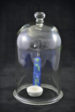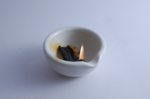  Given that Ss can only collect data if the teacher is able to demo and share live data remotely, it is more likely that sharing the completed data table (from the TE version of the SE) and discussing it will be the best way to support Ss in making sense of key ideas from this activity.  Key: Food provides energy and building materials for the body’s cells. More strenuous activity requires the body to use more energy to perform various tasks in the cells. | SE Activity 1.2  Setup Video 1.2  Image: probe  Image: tortilla chip  Activity Video 1.2 - CO2 and O2 Sensor Demonstration  Activity Video 1.2 - Burning in a Closed Environment | SE Activity 1.2  Print PI: Tortilla Chips Nutrition Facts
Reading Two | How Can I Learn More about How Food Provides Energy to My Body?  Key: Compares the burning tortilla chip demonstration to a reaction that might happen inside the body for energy. Also: Addresses common misconceptions that sleep, caffeine, exercise, or the sun provide energy for the body. | SE Reading Two | SE Reading Two
Checkpoint: Teachers may want to have Ss write a scientific explanation in the CER format for the question, “How does the energy released when food burns outside your body compare with what happens inside your body so that the food you eat can provide you with energy?”

Lesson 2  (1-2 sessions) | What Do Plants Need to Grow? | Download Lesson 2 Teaching Slides
ACTIVITY | TEACHING RECOMMENDATIONS | DIGITAL RESOURCES | PRINT RESOURCES | MATERIALS  FOR EACH STUDENT
Activity 2.1  What Should I Consider When Designing Scientific Investigations? | Have Ss read the scenarios and answer the questions. Recording key elements of their answers on a shared document would be helpful for Ss to be able to apply later in the unit.  Given the likelihood of reduced time for remote learning, Lesson 2 could be addressed in a single remote session.  Key: In an experimental design, all variables need to be constant except one, and repeated trials with comparisons are important. | SE Activity 2.1 | SE Activity 2.1 | Stopwatch
Activity 2.2  What Do Plants Need to Grow? | This investigation cannot be done remotely unless Ss have the space and materials. Alternatively, teachers could set up the experiment, record what happens and have Ss analyze the data. Setting some plants in the light and some in the dark would help them answer the question about whether plants need light.  Note: Although Ss likely already have this understanding, the more direct experience of the phenomenon will help solidify understanding needed throughout the unit as they consider photosynthesis and respiration, and the interrelationships of plants and animals.  Key: Plants need particular conditions to grow. | SE Activity 2.2 | SE Activity 2.2
Reading One | What Do Plants Need to Grow?  Key: Ss obtain information about designing good investigations. | SE Reading One | SE Reading One

Lesson 3  (2-3 sessions) | Do Different Foods Provide Different Amounts of Energy? | Download Lesson 3 Teaching Slides
ACTIVITY | TEACHING RECOMMENDATIONS | DIGITAL RESOURCES | PRINT RESOURCES | MATERIALS  FOR EACH STUDENT
Activity 3.1  Do Different Food Molecules Provide Different Amounts of Energy? | Demo this investigation, if possible; otherwise, share and discuss PIs and have Ss make predictions.  PIs:  - Oil Nutrition Facts  - Marshmallow Nutrition Facts  - Potato Chips Nutrition Facts  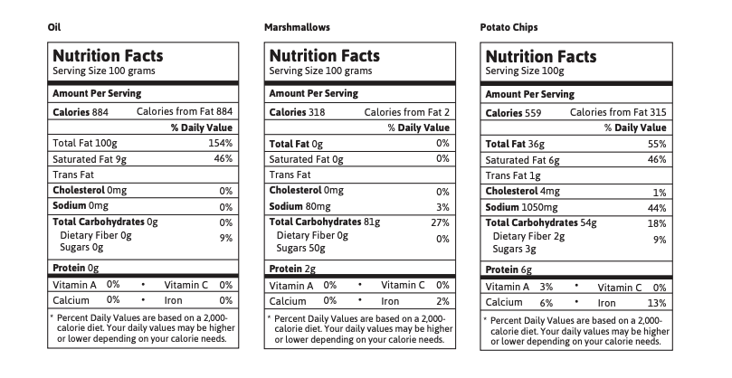  Share setup video: Burning Different foods. Ss can make observations while watching the video.  Share Image Data from Activity 3.1 (TE version of the SE), which Ss should copy in their SEs. (shown below)  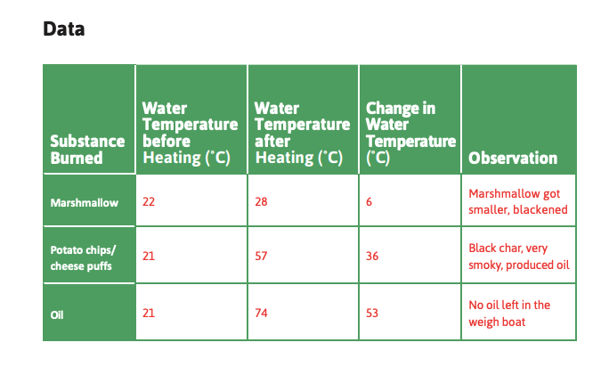  Key: Different types of food molecules, when reacting with oxygen, provide the body with different amounts of energy. Fat provides the most energy; protein and carbohydrates provide less. | SE Activity 3.1  Setup Video Activity 3.1 : Burning Different Foods  Activity Video 3.1 - Burning Marshmallows  Activity Video 3.1 - Burning Potato chips  Activity Video 3.1 - Burning Cooking Oil | SE Activity 3.1  Print PIs:  •Oil Nutrition Facts  •Marshmallow Nutrition Facts  •Potato Chips Nutrition Facts  Print Image of Data from Activity 3.1
Reading One | Do Different Food Molecules Provide Different Amounts of Energy?  Key: Fat molecules provide the body with more than twice as much energy as carbohydrate or protein molecules. | SE Reading One | SE Reading One
Activity 3.2  Do Different Food Molecules Provide Different Amounts of Energy? | Share Image: Glucose molecule. Show the chemical structure for glucose and relate the written model to the 2D model. If possible, show the Setup Video: Glucose Molecule Model and then the model of glucose. Teachers may want to display a computer model of the other molecules mentioned in the Introduction to illustrate how the atoms in glucose molecules can be combined to form other types of molecules.  Share PI: Food Molecules. What Ss have learned about carbohydrates also applies to proteins.  Ss need to complete the procedure and build carbohydrate, protein and fat models in their SEs.  Key: Different food molecules— carbohydrates, proteins, and fats— provide cells with different amounts of energy based on their number, type, and the arrangement of atoms that make up the molecules. | SE Activity 3.2  Activity Video 3.2 - Oil and Water  Setup Video: Activity 3.2 Glucose Molecule Model  Activity Video 3.2 - Glucose and Carbohydrates  Image of Constructing a Glucose Molecule | SE Activity 3.2  Print:  Image of Glucose molecule  Print PI:  •Food Molecules
Reading Two | Why Do Different Food Molecules Provide Different Amounts of Energy?  Key: Reviews molecular models of carbohydrates, fats, and proteins and describe their similarities and differences. (Note: This reading contains many new ideas about the structure of molecules that Ss will likely find challenging. The goal is to understand the concepts, not to memorize the vocabulary.) | SE Reading Two | SE Reading Two
Activity 3.3  How Much Do I Need to Exercise? | Re-share the nutrition facts for oil, marshmallows and potato chips using the PIs. If possible, show Ss 100 g of each item so that they have a visual comparison. Relate these to exercise. Ss can make predictions in the procedure and then do the calculations, completing the table and sharing data, if possible.  Key: The more energy that can be released from food molecules, the longer you have to exercise to use the energy. | SE Activity 3.3 | SE Activity 3.3  Print PIs:  •Oil Nutrition Facts  •Marshmallow Nutrition Facts  •Potato Chips Nutrition Facts  •Food Molecules
Reading Three | How Much Do I Need to Exercise?  Key: Food molecules are important because they provide the cells of the body with energy. Ss should be careful about what they eat because they need to balance the amount of energy that they are taking in with the amount of energy that they are converting to do things. | SE Reading Three | SE Reading Three

Learning Set 2: What Do Organisms Do with Food?
Lesson 4  (1 session) | How Do Food Molecules Provide Organisms with Building Materials? | Download Lesson 4 Teaching Slides
ACTIVITY | TEACHING RECOMMENDATIONS | DIGITAL RESOURCES | PRINT RESOURCES | MATERIALS  FOR EACH STUDENT
Activity 4.1  How Does My Mouth Change Carbohydrates? | Share PI: Cracker Nutrition Facts and PI: Simple and Complex Carbohydrates and discuss. If possible, have Ss chew a cracker and notice the change of taste from not sweet to sweet. Discuss chemical digestion in the mouth.  Part 1:  Have Ss make a prediction. Show the setup video: Testing Foods for Sugar and Starch-Teacher Setup. Pause the video on the results at the end, so Ss can complete the Data Collection/Observation in their SE. Alternatively, share a completed data table (In the TE version of the SE). Also show PI: Test for Starch and Glucose.  Part 2:  Teachers may want to explain how the next part of the investigation simulates digestion in the mouth by adding the enzyme that is responsible for chemically breaking down starch in their mouths to a cracker. Have Ss read the Procedure for Part 2 before sharing the Setup Video: Testing Foods for Sugar and Starch-Student Setup. Have Ss record the results from the video or from the expected results photo in the TE. Teachers could also show the completed data table (in TE version of the SE).  Share PI: Closer Look at Breakdown and PI: Starch Break Down during discussion to solidify understanding of concepts.  Refer Ss to the graphic organizers in the SE and have them fill in the appropriate boxes.  Key: Large food molecules (matter) are broken down through a chemical reaction in the body. | SE Activity 4.1  .  Setup Video: Activity 4.1 Testing Foods for Sugar and Starch-Teacher Setup.  Setup Video: Activity 4.1 Testing Foods for Sugar and Starch-Student Setup  Activity Video 4.1 Teacher Demo Sugar Breakdown | SE Activity 4.1  Print PIs:  •Cracker Nutrition Facts  •Simple and Complex Carbohydrates  •Test for Starch and Glucose  •Closer Look at Breakdown  •Starch Break Down | (1)cracker
Reading One | How Does My Mouth Change Carbohydrates?  Key: Breakdown of food in the body is a chemical reaction involving enzymes. | SE Reading One | SE Reading One
Checkpoint: The self-test in the reading could be used as an assessment to check Ss understanding of chemical breakdown.

Lesson 5  (2-3 sessions) | How Are Food Molecules Built Up and Stored? | Download Lesson 5 Teaching Slides
ACTIVITY | TEACHING RECOMMENDATIONS | DIGITAL RESOURCES | PRINT RESOURCES | MATERIALS  FOR EACH STUDENT
Activity 5.1  Where Do Proteins Go When They Are Eaten? | Share PI: How Have You Changed from Birth Until Now? Discuss growth in terms of the number of cells (and food being used as building materials). Have Ss read the research article and answer the questions.  Teachers should build the leucine molecules, and after Ss have read the “Methods” section, show them how the molecules can be combined to form a protein. Alternatively, share PI: Two Protein Submodules Build Up to Form One Molecule. The Setup Video: Amino Acid Molecule shows how an amino acid molecule is built.  Share: Comparison of Chemical Reactions. Ss should fill in the row for chemical reactions building molecules in the organizer of chemical equations in their SE.  Key: The building up of large molecules from submodules is a chemical reaction in both plants and animals. | SE Activity 5.1  Setup Video: Activity 5.1 Amino Acid Molecule | SE Activity 5.1  Print PIs:  •How Have You Changed from Birth Until Now?  •Two Protein Submodules Build Up to Form One Molecule  •Comparison of Chemical Reactions
Reading One | What Allows Organisms to Grow?  Key: Discusses repair and growth and the chemical reaction that builds up food molecules--involves comparison of children with sufficient food to those without. | SE Reading One | SE Reading One
Activity 5.2  Do Animals and Plants Store Food for Later? | Teachers may choose to have Ss watch the movie “Super Size Me” (100 minutes) or segments of the movie to demonstrate that weight gain is evidence that the body can store energy for food. Provide discussion prompts for Ss response or for discussion after viewing the video.  Key: Animals store food for long periods of time. The reading discusses chemical reactions related to storage. | SE Activity 5.2 | SE Activity 5.2
Reading Two A | Do Animals and Plants Store Food for Later?  Key: Animals store food for long periods of time. The reading discusses chemical reactions related to storage. | SE Reading Two A | SE Reading Two A
Reading Two B | Plants Also Store Food Molecules for Long Periods of Time  Key: Plants also store food molecules for long periods of time as carbohydrates and proteins are converted to fat. | SE Reading Two B | SE Reading Two B

Learning Set 2: Where Does the Energy in Food Come From?
Lesson 6  (1 sessions) | What Do Plants Need to Grow? | Download Lesson 6 Teaching Slides
ACTIVITY | TEACHING RECOMMENDATIONS | DIGITAL RESOURCES | PRINT RESOURCES | MATERIALS  FOR EACH STUDENT
Activity 6.1  What Do Plants Need to Grow? | If teachers were able to do Activity 2.2 about plant growth as a demonstration, they may discuss why plants need light to grow.  Teachers may do the Burning Wheatgrass Demonstration about energy conversion and discuss the original source for the chemical energy. otherwise share the video and discuss.  Ss should complete the graphic organizer for “Plants in the Light” --products and energy involved.  Key: Plants need light and water, but do not need soil. Food molecules react with oxygen to produce carbon dioxide and water. | SE Activity 6.1  Activity Video 6.1 : Burning Wheatgrass | SE Activity 6.1
Reading One | What Do Plants Need to Grow?  Key: Ss obtain information about an experiment a scientist conducted to confirm plants do not get what they need to grow from soil. | SE Reading One | SE Reading One

Lesson 7  (2 sessions) | How Do Plants Make Their Own Food? | Download Lesson 7 Teaching Slides
ACTIVITY | TEACHING RECOMMENDATIONS | DIGITAL RESOURCES | PRINT RESOURCES | MATERIALS  FOR EACH STUDENT
Activity 7.1  What Do Plants Produce in the Light? | Part 1: Starch  Have Ss read the procedure and predict whether they would expect to find food molecules in a plant leaf grown in the light and dark. Ss. should record data.  Have Ss record the data in the data table and complete the Making Sense question.  Share Video: Oxygen probe with water and a plant. Ss can see the setup and record data. Ss should answer the Making Sense questions. Teachers may also choose to share the image of plants grown in light and dark and data collected shown below.  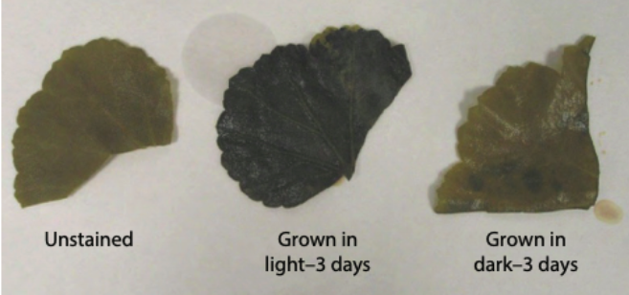  Key: Plants in the light consume CO₂ and water to produce oxygen and glucose. | SE Activity 7.1  Activity Video 7.1: Geranium Leaf | SE Activity 7.1  Print:  image  Plants in dark and lIght  Image of data from Plants in dark and light
Reading One | What Do Plants Produce in the Light?  Key: Reviews the products of photosynthesis, and stresses plants as the source for all food, and light as the original source of energy used by all living things. | SE Reading One | SE Reading One
Activity 7.2  How Do I KNow that Plants Use Carbon Dioxide? | Have Ss read the Procedure, predict and then watch Setup Video: Elodea in BTB solution. Share activity video, to help them fill in the Data Collection/Observations. They should then fill in the information in the graphic organizer of chemical reactions about plants in the light. Teachers might also choose to share data tables below  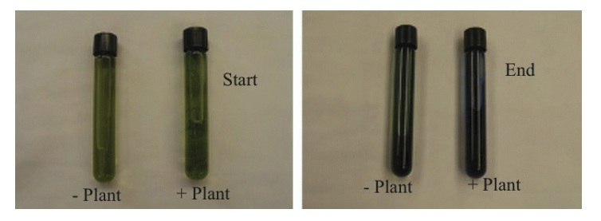  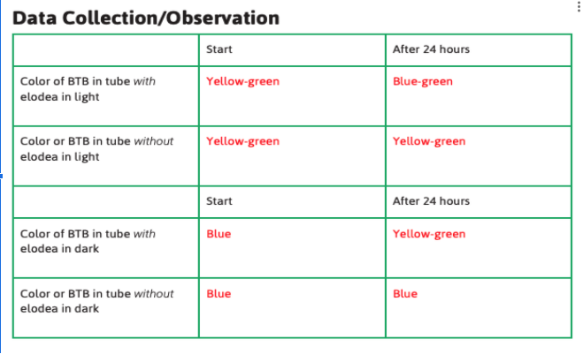  Key: Plants use carbon dioxide in the light. | Setup Video: Activity 7.2 Elodea in BTB solution  Activity Video 7.2 - Elodea and BTB | Print:  Image  Data table Activity 7.2
Reading Two | How Do I Know that Plants Use Carbon Dioxide?  Key: Plants need carbon dioxide and water to make oxygen and glucose. | SE Reading Two | SE Reading Two
Activity 7.3  What Do Plants Produce in the Light? | If Ss have access to items for modeling building, have them make one molecule of carbon dioxide and one molecule of water first.  Share PI: Photosynthesis. Have Ss make 6 molecules of carbon dioxide and 6 of water. Then have them break them apart and make 6 molecules of oxygen and one molecule of glucose. Ss can draw what they did in the SE.  Key: Plants convert light energy into chemical energy. Photosynthesis is a chemical reaction that uses energy from the sun and the reactants carbon dioxide and water to form glucose and molecules of oxygen. | SE Activity 7.3 | SE Activity 7.3  Print PI:  Photosynthesis | Toothpicks, gumdrops, colored mini marshmallows, or other items for model building (6 of one color, 12 of a second color and 18 of a third color)

Lesson 8  (1 sessions) | What Can Burning Food Teach Me about Food Providing Energy to My Body? | Download Lesson 8 Teaching Slides
ACTIVITY | TEACHING RECOMMENDATIONS | DIGITAL RESOURCES | PRINT RESOURCES | MATERIALS  FOR EACH STUDENT
Activity 8.1  What Does Food Need to Burn? | Ss should predict what will happen when oil is burned in a closed system. Have Ss read the Procedure and then demo the investigation or share the Setup Video: What Does Food Need to Burn?  Share and discuss image of data from Activity 6.1 shown below  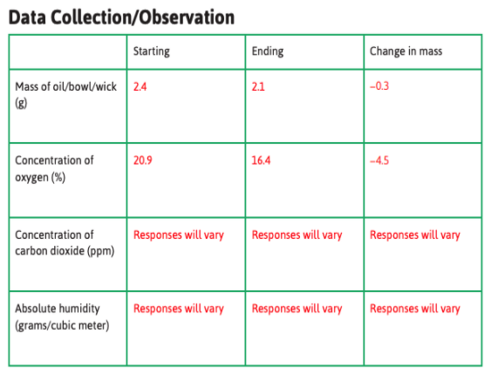  Share and discuss PIs:  - Data from Activity 8.1 for Ss to copy in their SEs.  - Chemical Reaction for Burning Oil.  - Burning Food Molecules.  Have Ss complete the graphic organizer of chemical reactions for burning food in their SEs.  Key: Food molecules react with oxygen to produce carbon dioxide and water.  Key: Burning reactions convert energy to light and thermal energy which is felt as heat. | SE Activity 8.1  Activity Video Coming Soon  Setup video: Activity 8.1 What Does Food Need to Burn? | Print  Image Data from Activity 6.1  Print PIs: •Chemical Reaction for Burning Oil  •Burning Food Molecules
Reading One | What Can Burning Food Teach Me about Food Providing Energy to My Body?  Key: Burning food outside the body, and the way in which food provides energy inside the body are similar reactions. | SE Reading One | SE Reading One

Lesson 9  (1-3 sessions) |  | Download Lesson 9 Teaching Slides
ACTIVITY | TEACHING RECOMMENDATIONS | DIGITAL RESOURCES | PRINT RESOURCES | MATERIALS  FOR EACH STUDENT
Activity 9.1  Does a Reaction Similar to Burning Happen in My Cells? | Given the likelihood of reduced time for remote learning, activities in this lesson could be combined into fewer sessions. Teachers may want to review systems in the body with Ss. For example, combine A. 9.1, A.9. by sharing PI: Glucose Levels in the Blood, sharing the videos provided for A.9.2 combine this with Reading One and Two and discuss. Activity 9.3 could be omitted in the likelihood or reduced time constraints as well using only.  Teachers may want to review systems in the body with Ss.  Share PI: Starch Breaks Down to remind Ss of the chemical breakdown of starch.  In Lesson 1 Reading One they found that they breathe out less oxygen than they breathe in. Use PI: The Respiratory System and PI: Gas Exchange in the Alveoli to tie in what they now know about oxygen.  Have Ss look at the data from Activity 2.1. Share PI: Capillaries and Small Intestine and PI: Circulatory System and have Ss explain how the carbon dioxide produced by every cell leaves the body.  Part 1:  Have Ss predict. Then have them analyze the data in the activity and answer the questions.  Ss should fill in the appropriate rows of the graphic organizer of chemical reactions.  Share PI: Cellular Respiration.  Key: Cellular respiration releases energy as organisms use oxygen and food molecules and produce water and carbon dioxide. | SE Activity 9.1 | SE Activity 9.1  Print PIs:  •Starch Breaks Down  •Burning Food Molecules  • Capillaries and the Small Intestine  •The Circulatory System  •The Respiratory System  •Gas Exchange in the Alveoli  •Cellular Respiration
Reading One | Does a Reaction Similar to Burning Happen in My Cells?  Key: Ss read about what happens in the body when cells do not get enough oxygen. Sickle cell anemia is discussed. | SE Reading One | SE Reading One
Activity 9.2  How Do Food Molecules Provide Plants with Energy? | Share PI: Comparing Photosynthesis and Cellular Respiration. Discuss this in relation to the investigation with elodea and BTB. Share Comparing Photosynthesis (2x) and Cellular Respiration. Again, discuss this in relation to the investigation with elodea and BTB. Discuss the two hypotheses that arise from this (as outlined in the TE).  Part 1:  Have Ss predict. Share Video: Elodea + BTB. Have Ss record data from Image:Data Data for Color of BTB (top half of the data table in the TE version of the SE), shown below.  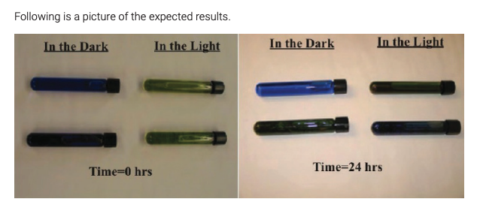  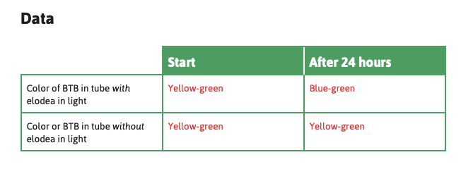  Share Video: Activity Video Testing for Carbon Dioxide-Student. Have Ss record data from Image: Oxygen Data You may want to show them pictures of the results that are in the TE. (Oxygen Data table is shown below)  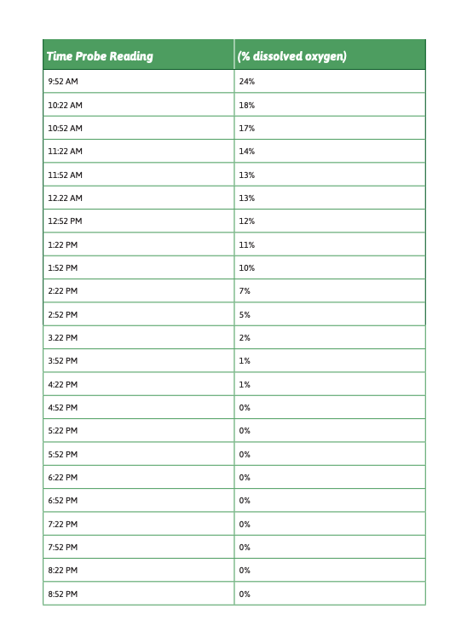  Part 2:  Share Setup Video: Elodea Demo 2. Share PI: Oxygen data. Discuss the two hypotheses and which one the data support.  Part 3: Glucose  Discuss the results of the investigation with geranium leaves and how this relates to the results from the other two investigations. Have Ss complete the Making Sense questions.  Share PI: Chemical Reactions in Plants and discuss. Have Ss fill in the graphic organizers under “Plants in the light” and “Plants in the dark.”  Key: During cellular respiration, plants use oxygen and food molecules and produce water and carbon dioxide. | SE Activity 9.2  Video: BTB  Setup Video 9.2A  Setup Video 9.2B  Setup Video 9.2C  Activity Video 9.2: Part 1- Carbon Dioxide -Test tubes in the dark  Activity Video 9.2 - Part 1 - Carbon Dioxide - Test tubes in the light  Activity Video 9.2- Part 2 - Oxygen - Dissolved Oxygen  Image: Data for Color of BTB  Image: Oxygen Data | SE Activity 9.2  Print PIs: •Comparing Photosynthesis and Cellular respiration  •Comparing Photosynthesis (2x) and Cellular Respiration  •Chemical Reaction in Plants  Image: Data for Color of BTB  Image: Oxygen Data
Reading Two A | How Do Food Molecules Provide Plants with Energy?  Key: Plants have starch (food) which they use in the dark for cellular respiration. Plants use oxygen. | SE Reading Two A | SE Reading Two A
Reading Two B | Do Plants Give Off Carbon Dioxide?  Key: Plants do both Photosynthesis and Cellular Respiration. | SE Reading Two B | SE Reading Two B
Activity 9.3  How Do Food Molecules Provide Energy? | If possible, have Ss model the process of cellular respiration with gumdrops. Alternatively, the teacher could demonstrate by modeling the process of cellular respiration using gumdrops.  Key: Cellular respiration is the chemical reaction that provides energy to the cells of an organism. During cellular respiration, organisms (plants and animals) use oxygen and food molecules and produce water and carbon dioxide. | SE Activity 9.3 | SE Activity 9.3 | Gumdrops (6 of one color, 12 of a second color and 18 of a third color)
Reading Three | How Can I Tell that Food Molecules Provide My Cells with Energy?  Key: Ss will read about the similarities and differences between burning and cellular respiration. Burning is a chemical reaction with one step, while cellular respiration has many steps. The reactants and products are the same. | SE Reading Three | SE Reading Three
Checkpoint: In A.9.1, Making Sense question 4 can be used to assess Ss ability to account for all the evidence and scientific principles that completely answer the question, “What happens to fat stored in the body when people lose weight?” The following can be asked to assess Ss ability to apply cellular respiration (and energy types) to the anchoring phenomenon: How does cellular respiration relate to the exercising activity from lesson 1 (e.g. muscles contracting, lungs breathing, heart beating, etc.)?

Lesson 10  (2-3 sessions) | How Do Matter and Energy Move between Organisms? | Download Lesson 10 Teaching Slides
ACTIVITY | TEACHING RECOMMENDATIONS | DIGITAL RESOURCES | PRINT RESOURCES | MATERIALS  FOR EACH STUDENT
Activity 10.1  How Does Matter Transfer between Organisms? | Teachers may want to provide Ss with a completed table (in the TE version of the SE) for discussion rather than having Ss work independently to complete the table and Making Sense questions.  Key: Both the plant and mouse perform cellular respiration. During cellular respiration, plants and animals use food and water and produce CO₂. Only plants perform photosynthesis. During photosynthesis, plants use CO₂ and water and produce food and O₂. The substances (matter) in these two chemical reactions cycle between the plant and plant + mouse | SE Activity 10.1 | SE Activity 10.1  Completed data table form A.10.1
Reading One | How Does Matter Transfer between Organisms?  Key: Ss obtain information about how the carbon atom cycles between plants and animals in an ecosystem. | SE Reading One | SE Reading One
Activity 10.2  How Does Energy Move between Organisms? | Have Ss choose one of the organisms (algae, mice, aquatic insects, foxes, aquatic plants) answer the SE questions about their organism, and then draw the movement of carbon-containing molecules through their organism. Modeling enables Ss to work through matter and energy one at a time (the first two PIs below), then both, and then to examine the complexity of ecosystem cycles.  Share PIs:  - Carbon Flow between Five Organisms  - Energy Flow between Five Organisms  - Carbon Cycle and Energy Flow  - Great Lakes Food Web  Key: An ecosystem needs a constant input of light energy. As light energy enters the environment, plants use the energy for photosynthesis to create food molecules. These food molecules are used by plants and animals in cellular respiration to produce energy for cells.  Key: Carbon in the environment can cycle from food molecules to carbon dioxide through photosynthesis and cellular respiration. | SE Activity 10.2 | SE Activity 10.2  Print PIs  *Carbon Flow between Five Organisms  •Energy Flow between Five Organisms  •Carbon Cycle and Energy Flow  •Great Lakes Food Web | (1)piece of paper
Reading Two | How Does Energy Flow through the Environment?  Key: The carbon cycle is connected to the flow of energy with photosynthesis and cellular respiration. | SE Reading Two | SE Reading Two
Activity 10.3  How Can the Flow of Matter and Energy Change? | Ss use their model of cycles of photosynthesis and cellular respiration and the energy flow associated with these chemical reactions to predict what will happen in a scenario of their choosing. Some possibilities are provided in the TE.  Key: Changing anything about photosynthesis and cellular respiration and the energy flow associated with these chemical reactions will affect an ecosystem (and beyond). | SE Activity 10.3 | SE Activity 10.3
Reading Three | What Else Is There to Learn about Energy?  Key: Some bacteria make food from iron and others from sulfur. Some bacteria and yeast get energy from food molecules without using oxygen. | SE Reading Three | SE Reading Three

SUMMATIVE ASSESSMENT: Ss now have all the information they need to write a CER-formatted explanation that addresses the Driving Question: How Does Food Provide My Body with Energy? Ss should draw on what they have learned (e.g., Scientific Principles), data to be used as evidence, and any artifacts from the unit to write a complete, detailed explanation. Alternatively, Ss could create and explain a concept map or a flow chart in order to answer the Driving Question.

Teachers might choose to emphasize only a portion of this as a final assessment, given what they are able to teach and what Ss are actually able to do during this remotely taught unit.

