REMOTE LEARNING LESSON PLANS
The Remote Learning Lesson Plans are adapted from the IQWST Teacher Edition to support continuous learning. Each plan condenses what is taught with specific teaching recommendations and identifies the digital resources, print resources, and materials needed to teach and learn IQWST remotely.

UNIT TITLE | PS1
DRIVING QUESTION | Can I believe my eyes?
UNIT STORYLINE | PS1 Storyline
IQWST OVERVIEW | IQWST 3.0 Overview
TEACHER EDITION | PS1 Teacher Edition
STUDENT EDITION | PS1 Student Edition
LESSON PLAN OVERVIEW | Remote Learning Overview

STUDENT MATERIALS: Each student will need the following materials. Teachers can modify lessons based on which materials the students have access to. For Blended Learning options, teachers may draw from a combination of digital and print resources.
DIGITAL RESOURCES | PRINT RESOURCES | MATERIALS NEEDED (FOR EACH STUDENT)
- Access to Interactive Student Edition  - Access to teacher-led lesson or video  - Access to IQWST lesson videos  - Audio recordings of readings  Access from any device with a web browser.  - For PCs and Chromebooks, we recommend using Chrome as the browser  - For Macs and iOS, we recommend using Safari as the browser  - Internet Explorer is NOT supported  - Read the full Technical Requirements here  Login: http://activatelearning.com/digital-resources/  - Select your program  - Enter the Username and/or Password provided by your teacher | - PS1 Student Edition  - Hard copies of selected Projected Images (PIs)  Print student editions are necessary for students who do not have internet access (or reliable access). | IQWST Equipment (from kit)*  1 lightbox or shoebox  1 statuette  modeling clay  6-9 small toy cars  1 small ball  1 flashlight  1 small, plastic mirror  1 small, plastic comb  1 index card  1 C-spectra paper (2”x2”)  Household Items  6 solid objects of various sizes and shapes  several sheets of white paper  clear container (e.g. drinking glass) to hold water  water  Students may also need the following General Classroom Supplies (if not using the IDE):  Pencils and sharpener  Colored pencils  Black marker and/or ink pen  Plain paper for drawing (10-20 sheets)  Glue stick or transparent tape  Pad of sticky notes  Scissors  * If kits have been purchased, they include enough equipment for 8 groups of 4 students. You will need additional equipment if you opt to provide materials to each student.

Learning Set 1: How Does Light Allow Me to See?
Lesson 1  (1 session) | Do You See What I See? | Download Lesson 1 Teaching Slides
ACTIVITY | TEACHING RECOMMENDATIONS | DIGITAL RESOURCES | PRINT RESOURCES | MATERIALS  FOR EACH STUDENT
Activity 1.1  Anchoring Activity— Strange Images | Anchoring Phenomenon: To generate interest, students (Ss) observe images that involve light and shadow and that trick the eyes and brain (i.e., optical illusions) in Activity 1.1. Lesson 2 provides an additional phenomenon to anchor learning throughout the unit: Objects can be seen only when light, the object, and the eye align in particular ways.  Anchoring Activity— Strange Images  Share PIs (PIs) and do activity as written in the TE. All PIs are embedded in the slide deck or can be accessed via the Teacher Portal.  - Moving Circles  - Checkerboard  Given the likelihood of reduced time for remote learning, time could be reduced by combining Activity 1.1 and 1.2 into a single session.  Discussion Prompts: Throughout the unit, teachers should: 1) choose discussion prompts applicable to remote learning and ability to discuss with Ss, or 2) have Ss write answers to teacher-selected prompts that can be added to the slide deck, if discussion is not possible, or 3) choose questions for Ss to discuss remotely, perhaps writing responses that are then submitted.  Questions in the SEs: Throughout the unit, teachers should decide on the method by which the lesson will be delivered, and then have Ss ignore any questions in their SEs that do not fit the way in which the lesson needed to be enacted remotely. Teachers may provide a handout for print-only Ss who cannot access the curriculum remotely, so that they know which questions in their SEs they should respond to.  Key: Pique Ss interest in what and how people see. | Access to Student Edition (SE) in Interactive Digital Edition (IDE) | Hard copy of the Student Edition (SE) to be used for all activities,  readings, writing tasks.  Print PIs:  - Moving Circles  - Checkerboard  In addition, the readings in the SE connect in-class investigations of phenomena with other, everyday phenomena that Ss have either experienced or with which they are familiar.
Reading One | See TE for Reading Intro and Followup.  Ss may be able to do the “Were the Images in Class Optical Illusions?” section remotely.  Key: Illusion (something appears to be what we know it is not) vs reality of what we see. | SE Reading One | SE Reading One
Activity 1.2  Driving Question Board | The opening Brainstorming Discussion is important to stimulate thinking about sources of light and about vision and sight so that Ss begin to ask questions.  Introduce the Driving Question Board (DQB): Throughout the unit, Ss record their own, original questions as they arise. See IQWST Overview for more information on how to use and manage the DQB.  Elicit and post Ss questions to a central DQB if possible.  Key: Lesson 1 piques Ss interest and raises the Driving Question as a question Ss will be investigating across time.. | SE Act 1.1 & 1.2  Teacher-created DQB (e.g., jamboard, padlet) or physical DQB to share during virtual lessons. | SE Act 1.1 & 1.2  Ss will write questions on sticky notes, and post at the front of their SEs on the Driving Question Notes pages. | Pad of sticky notes  Pencils/pencil sharpener  Black marker

Lesson 2  (1-2 sessions) | What Do We Need to See an Object? | Download Lesson 2 Teaching Slides
ACTIVITY | TEACHING RECOMMENDATIONS | DIGITAL RESOURCES | PRINT RESOURCES | MATERIALS  FOR EACH STUDENT
Activity 2.1  Probing Ideas: Seeing Objects around the Room | Anchoring Phenomenon: Lesson 2 establishes the conditions for seeing via patterns in Ss observations. This lesson lays the groundwork for remaining lessons, in which Ss will investigate (and explain) various phenomena in which light interacts with matter.  Share PIs:  - What Affects Sight?  - What Hinders Sight?  - What Can You See?  Using prompts in the TE, discuss patterns of what can and can’t be seen in the images (from different vantage points). Discuss the conditions for sight.  This 2nd part of the activity can be adapted for remote learning in the following way:  - Have Ss gather 6 objects: Any 6 items, there is no right or wrong for this activity.  - Ss should make a list of the 6 items for SE Procedure Step c.  - Have Ss choose a place they will sit (at a table, on a bed, on the floor), and put the items somewhere in the same room where they will sit. (A partner--or others--who will do the activity with Ss, sitting in other places in the room, facing different directions, will add to the learning and enable discussion. This can be done with younger siblings, as well.)  - Ss should put something behind, something in front, some things off to the side toward the front, and some off to the side toward the back, something under the place they will sit.  - Now: Sit where they intended. Without turning their heads, can they see Item 1? (And can anyone doing the activity with them see Item 1?)  - Ask the same question about each of the 6 items.  - With each item consider: Why can they see each one they CAN see? And why CAN’T they see each one they can’t see? What is the difference between who can see it and who can’t see it? (Or if doing it alone, what is the difference between what they can see and what they can’t see?)  - Answer Making Sense Question #1.  Key: A straight and unblocked path is needed to see an object. (That is, nothing can be “in the way” or “blocking” the line of sight.) | SE Activity 2.1 | SE Activity 2.1  Print PIs:  - What Affects Sight?  - What Hinders Sight?  - What Can You See? | 6 objects  This investigation can be done individually, with a partner, or with others (an adult, friend, or siblings can participate).  Only 6 objects are needed regardless of the number of participants.
Reading One | Picture This!  Given the likelihood of reduced time for remote learning, time could be reduced by skipping this reading. However, the How Do People See Objects Around Them? section and its questions emphasize light’s path.  Key: We can see anything from which light can enter our eyes, either because we see the light directly, or because the light bounces off of an object with a clear path to our eyes. | SE Reading One | SE Reading One
Activity 2.2  Determining the Conditions for Sight— The Light Box | Demo the activity, if possible. Otherwise, share the video.  This lesson is very important for learning the core concepts of the unit, as it challenges key misconceptions about light and seeing (e.g., that our eyes “adjust to the dark” so that we can see in an unlit room). This activity is do-able remotely only if Ss are provided with the light box or a shoebox that should be cut by an adult. If this is not possible, focus on the video as well as on Activity 2.1 to anchor the unit.  Key: Four conditions are necessary for humans to see an object: Light, an object to be seen, a straight and unblocked path between the object and the eye, and a working eye. | SE Activity 2.2  Activity Video 2.2 The Light Box | SE Activity 2.2 | (1) light box or shoebox with instructions for an adult to cut.  (1) statuette to put inside  modeling clay to hold statuette upright in box

Lesson 3  (1-2 sessions) | Constructing Models of How People See | Download Lesson 3 Teaching Slides
ACTIVITY | TEACHING RECOMMENDATIONS | DIGITAL RESOURCES | PRINT RESOURCES | MATERIALS  FOR EACH STUDENT
Activity 3.1  Preparing to Develop Models | Demo the modeling activity, or share the video as well as the images in the TE (shown here and included in the slide deck) to model the phenomenon of how light travels.  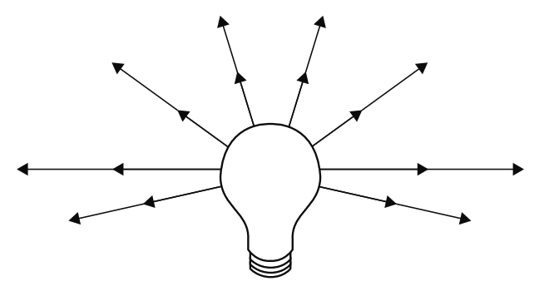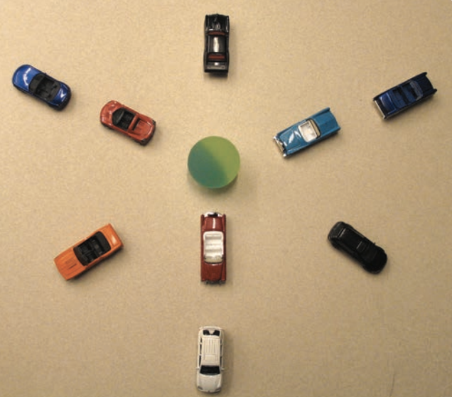  Teachers may choose to have Ss create their own 3D models with objects available to them remotely or using the icons in IDE. Teachers may also choose to share the sample consensus model from the TE (shown in Activity 3.2).  Key: Light travels in all directions.  Key: The role of modeling in science. | SE Activity 3.1  Activity Video 3.1 Teacher Light Ray Model | SE Activity 3.1 | (6-9) small toy cars  small ball  piece of modeling clay to keep ball from moving
Reading One | Modeling  Key: Understanding models and modeling as a scientific practice. | SE Reading One | SE Reading One
Activity 3.2  Building the Consensus Model | Ss turn their physical 3D models into 2D models, and then 2D models are discussed and become a class consensus model (shown here).  This consensus model will be revised--as all models are--when new information becomes available (in forthcoming lessons).  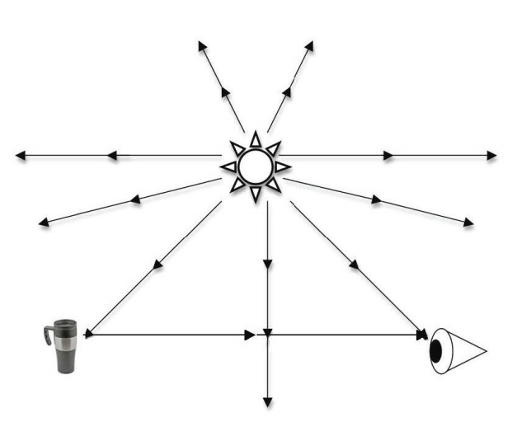  Key: The consensus model can be used to explain how people see objects. | SE Activity 3.2 | SE Activity 3.2  Print copy of the icons for creating a model. | Household objects for creating a model  Copy of Icons,  Blank paper, roll of tape, pencil
Reading Two | Faster than a Speeding Bullet  This reading could be skipped in order to save time during remote learning, or it could be supplemental reading for some Ss.  Key: The speed of light and why flipping a light switch results in instant light. | SE Reading Two | SE Reading Two
Checkpoint: Ss should be able to use the consensus model to explain the phenomenon: We see any object because light (from any light source) travels in straight lines, reaches objects, and bounces back into our eyes--if there is a straight, unblocked path between the object and our eyes.

Lesson 4  (0-1 session) | The Eye as a Light Sensor | Download Lesson 4 Teaching Slides
ACTIVITY | TEACHING RECOMMENDATIONS | DIGITAL RESOURCES | PRINT RESOURCES | MATERIALS  FOR EACH STUDENT
Activity 4.1  How the Eye Works— Overview | Given the likelihood of reduced time for remote learning, teachers may choose to omit this lesson.  Share PIs using slide deck or teacher portal:  - The Human Eye  - Tracing the Path of Light  Share the video on measuring the amount of light using a sensor.  Discuss the brightness of an object as a factor of how much light reaches the eye.  Key: The more light that reaches the eye from an object, the brighter the object appears. | SE Activity 4.1  Activity Video 4.1 Light Sensor Demo - How does the eye work? | SE Activity 4.1  Print PI:  - The Human Eye  - Tracing the Path of Light
Reading One | Eyes in the Animal Kingdom  Ss can do a quick activity remotely that shows the pupils adjusting to light.  This reading may be omitted; however, it is consistently named by Ss as their favorite and as their most-remembered reading in IQWST. See the Intro and Follow-up in the TE for ideas for using this reading.  Key: The physiology of eyes: They adjust to the amount of light available/entering them. | SE Reading One | SE Reading One | maglight or flashlight

Lesson 5  (0-1 session) | How Are Shadows Created? | Download Lesson 5 Teaching Slides
ACTIVITY | TEACHING RECOMMENDATIONS | DIGITAL RESOURCES | PRINT RESOURCES | MATERIALS  FOR EACH STUDENT
Activity 5.1  Connecting Shadows to the Light Model | Given the likelihood of reduced time for remote learning, the unit could be shortened by combining Activities 5.1 and 5.2 into a single session. Or, if more cuts are needed, teachers could omit the activities related to shadows. They are high interest, but less important than other lessons.  Demonstrate or direct Ss what to do remotely to explore shadows.  Share PIs:  - A Light Model  - Light Model 2  - Shadows  Key: After 5.1 and 5.2: A shadow is formed when light is blocked by an object, and the light that reaches the eye is the light that reaches the area around the object. | SE Activity 5.1 | SE Activity 5.1  Print PI:  - A Light Model  - Light Model 2  - Shadows | maglight or flashlight  piece of white paper
Activity 5.2  Connecting Shadows to the Light Model | This model can be challenging for Ss. Demo if possible, but the model for shadows is less important than building the understanding of what a shadow is.  Key: We don’t “see” a shadow---we see the light that is not blocked by an object, which is perceived as a shadow because no light is coming back to our eyes. | SE Activity 5.2 | SE Activity 5.2
Reading One | All Shadows Are Not the Same  The reading includes an activity that involves just the Ss own hand and a light source, and enables Ss to experiment with shadows.  This reading is challenging; therefore, teachers may choose to have Ss do only the “Try this...” section, and follow up with a discussion of what Ss learned from their investigation of shadows. The rest of this reading may be best skipped in a remote learning context. It could be a supplementary reading for some Ss. | SE Reading One | SE Reading One | Lamp or sun as a light source
Checkpoint: Making Sense questions #2 and #3 in Activity 5.2 enable teachers to check Ss understanding of what we actually see when we see a shadow. Or, they could be combined into a single question that asks Ss to compare two scenarios.

Learning Set 2: What Happens When Light Reaches an Object?
Lesson 6  (2 sessions) | Scattering and Reflection of Light | Download Lesson 6 Teaching Slides
ACTIVITY | TEACHING RECOMMENDATIONS | DIGITAL RESOURCES | PRINT RESOURCES | MATERIALS  FOR EACH STUDENT
Activity 6.1  Reflection  AND  Activity 6.2  Investigating Scattering and Reflection | Demo this investigation, or share the Setup Video and talk with Ss about what will be done. Then show the video of the investigation and the sensor measurements, having Ss focus on patterns in the data.  Teachers may also want to show the video of angle of reflection.  Ss who are unfamiliar with the idea of angles will benefit from this video. The “angle of incidence and reflection” are beyond the scope of the lesson; however, this video demonstrates the phenomenon that light travels in a straight line and that the angle of reflection is equal to the angle of the light entering the mirror. It is not necessary to use the sound on this video.  https://docs.google.com/document/d/1p1f3G6ZU-IomYuddxwFnHsXYFYis_SelM7BTQqViPjA/edit?usp=sharing  Teachers may also wish to share the data table from the video and discuss:  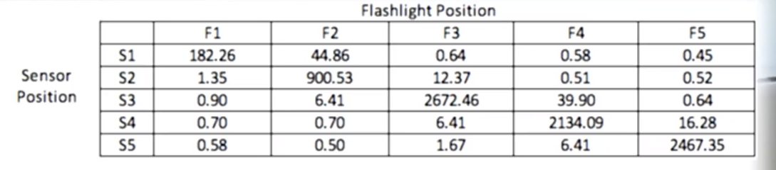  Key: At whatever angle a light strikes an object, some of the light is reflected, and always at the same angle as the light striking the object (light always travels in straight lines). | SE Activity 6.1 & 6.2  Setup Video 6.1-6.2  Activity Video 6.1 Angles: Reflection  Activity Video 6.2 Angles: Reflection and Scattering  Video: angle of reflection | SE Activity 6.1 & 6.2 | flashlight or maglight (a maglight will work better, so the beam can be focused, but either will work)  small plastic mirror  small amount of clay  small plastic comb  Index card  scissors
Activity 6.3  Explaining Scattering, Reflection, and Images | Given the likelihood of reduced time for remote learning, teachers may choose to omit this activity.  Share PIs:  - Paper Magnified  - Light Hitting a Surface  - Student Drawing Models  - Flashlight  - Flashlight Bouncing Off Wood  Key: Depending on the surface light strikes, it can be reflected (at a predictable angle) or scattered less predictably (but always in straight lines). | SE Activity 6.3  Activity Video 6.3 Scattering, Reflection, and Images | SE Activity 6.3  Print PIs:  - Paper Magnified  - Light Hitting a Surface  - Student Drawing Models  - Flashlight  - Flashlight Bouncing Off Wood | maglight or flashlight  small plastic mirror  piece of white paper
Reading One | Polishing Objects  Key: Polishing smooths a surface so that it reflects more light; however, no surface is perfectly reflective (with no scattering). | SE Reading One | SE Reading One
Checkpoint: The idea of light bouncing off of an object is refined to understanding that some amount of light is reflected (or scattered) and reaches our eyes. The phenomenon of one way that light interacts with matter (any object) by being reflected is key to this point.

Lesson 7  (2 sessions) | Transmission of Light | Download Lesson 7 Teaching Slides
ACTIVITY | TEACHING RECOMMENDATIONS | DIGITAL RESOURCES | PRINT RESOURCES | MATERIALS  FOR EACH STUDENT
Activity 7.1  Evaluating the Light Model | Demo the light box (from Lesson 2) again, if possible, so that Ss have a visual anchor for what their models need to represent. Ss then test the model under two conditions. If Ss are unable to see or use their own light box, they may need more support to conceptualize adding an opaque structure (such as cardboard) to their model. An opaque structure allows no light to enter the eye.  Then, add a transparent structure to the model and discuss the difference: People can see some thorough transparent material because light can enter the eye.  Key: The current light model doesn’t allow for transmission of light through a transparent object, so the model needs to be revised as a model of how we see. | SE Activity 7.1  Activity Video 7.1 Light Box Opaque and Clear Dividers | SE Activity 7.1
Activity 7.2  Measuring Light Transmission | Demo the activity using several flat objects to investigate light transmission.  If this activity is able to be taught, then demo the investigation, if possible. Otherwise, share the Activity Video.  Key: The modeling is important in 7.1, 7.2, and 7.3. Ss should understand that models need to be revised to account for phenomena they can no longer be used to explain. | SE Activity 7.2  Activity Video 7.2 Measuring Light Transmission  Activity Video 7.2 Sensor Data for Transparency of Materials. | SE Activity 7.2
Activity 7.3  Revising the Light Model | Share PI:  - Consensus Model  Key: See 7.2. | SE Activity 7.3 | SE Activity 7.3  Print PI:  - Consensus Model
Reading One | Using Light in Optical Fibers  Given the likelihood of reduced time for remote learning, this reading could be skipped, or it could be a supplementary reading for some Ss.  Key: Real-world application of what scientists and engineers know about light. | SE Reading One | SE Reading One

Lesson 8  (2-3 sessions) | Absorption of Light | Download Lesson 8 Teaching Slides
ACTIVITY | TEACHING RECOMMENDATIONS | DIGITAL RESOURCES | PRINT RESOURCES | MATERIALS  FOR EACH STUDENT
Activity 8.1  Light Makes Things Happen | Demo the phenomenon if possible. Otherwise, share the Activity Video and/or share radiometer videos and video of time-lapse heliotropism. Focus on the cause and effect relationship.  Key: Absorption. When light is absorbed, light energy is transferred to the object, and that energy transfer is experienced as heating the object. | SE Activity 8.1  Activity Video 8.1 Light Phenomena  Video 1: radiometer  Video 2: radiometer  Video: time-lapse heliotropism | SE Activity 8.1
Activity 8.2  Investigating Heating by Light | Demo the activity, or share the Setup and Activity Videos. Given that Ss are not able to do the activity remotely, also share sample data as needed.  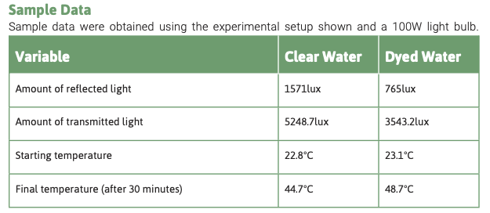  Given the likelihood of reduced time for remote learning, Activity 8.3 may be combined with 8.2 in a single remote session.  Key: When light is absorbed, it can make things happen (e.g., heats an object and makes it warm/hot). | SE Activity 8.2  Setup Video 8.2  Activity Video 8.2 Investigating Heating by Light | SE Activity 8.2
Reading One | Solar Power Plants  This reading provides real-world application of the heating-water investigation. If pressed for time, teachers may choose to skip the reading except the last two questions, as they reference Activities 8.1 and 8.2 and are not dependent on the rest of the reading. | SE Reading One | SE Reading One
Checkpoint: The two questions at the end of the reading provide an opportunity to assess Ss understanding of what happens when light interacts with matter, and how it differs depending on whether the light energy is absorbed, transmitted, or reflected.
Activity 8.3  Keeping Track of Light | Share the consensus model developed in Activity 3.1 and use it to consider the results of Activity 8.2.  Key: Light’s energy is conserved. All of the light energy can be accounted for as “here somewhere.” | SE Activity 8.3 | SE Activity 8.3
Activity 8.4  Revisiting Phenomena Caused by Light | Revisit the light-related phenomena from Activity 8.1  *Appendix Lesson 1 (which focuses on analog and digital signals and the wave model of light) cannot be done remotely. However, content in the TE could be addressed in Lesson 8, adding that light travels in straight lines but in a wave pattern. The Appendix 1 PI: Communication Signals shows the wave model of light, and the Background Knowledge section in the TE provides a great deal of information for teachers.  Key: Generalize the principle: When light reaches an object, it is reflected, absorbed, or transmitted (in some combination). | SE Activity 8.4 | SE Activity 8.4
Reading Two | Solar Energy  Teachers might have Ss read about any one of the examples in the SE rather than all examples.  Key: Real-world applications using what scientists and engineers understand about light. | SE Reading Two | SE Reading Two
Checkpoint: Light’s energy is conserved. All of the light energy can be accounted for.

Learning Set 3: How Can Light Have Different Colors?
Lesson 9  (1-2 days) | What Is the Opposite of White Light? | Download Lesson 9 Teaching Slides
ACTIVITY | TEACHING RECOMMENDATIONS | DIGITAL RESOURCES | PRINT RESOURCES | MATERIALS  FOR EACH STUDENT
Activity 9.1  Why Do We See Different Colors? | Note: Lesson 9 has been reworked and retitled: Why Do We See Different Colors? Both the reworked TE and SE pages are available as pdfs on the Portal. Click here to access the revised lesson in IDE.  The simulations in 9.1 and 9.2 need to be shown as teachers talk through them, or Ss need to manipulate the simulations directly. Activities 9.1 and 9.2 could be combined into a single lesson in which Ss identify patterns and draw conclusions from those patterns.  Note: Activity 12.2 focuses on waves, including that different wavelengths of (visible) light appear to us as different colors. Instead of using Activity 12.2 as a later lesson to contrast visible and non-visible light, teachers may want to combine the “visible light” phenomenon (Activity 12.2) here as it addresses the wave model and wavelengths of light. If Activity 12.2 is added here, this is also key learning: Different wavelengths of visible light appear to us as different colors.  Demo or share the simulation for color vision (single flashlight icon, single bulb).  Key: The more light that reaches the eyes, the brighter the color appears to our eyes. | SE Activity 9.1  Simulation: color vision | SE Activity 9.1
Activity 9.2  Mixing Colors of Light on Computers  Revised: How can we See New Colors of Light? | See instructions for 9.1. Demo or share the simulation for color vision (three flashlights icon, RGB bulb).  Click here to access the revised lesson in IDE.  Key: Black is the absence of color, meaning that no light is reflected into our eyes. (Perhaps connect to the idea that a shadow appears black.) | SE Activity 9.2  Simulation: color vision | SE Activity 9.2
Activity 9.3  How Color Sensors Work | This activity focuses on how eyes sense color. Given the likelihood of reduced time for remote learning, time could be reduced by skipping Activity 9.3.  If teachers choose to do this activity, share PIs and provide print copies for Ss who do not have internet access:  - Eye Close-Up (from Lesson 4)  - Eye Diagram  - Retina  - Parts of the Retina  - Camera PI: Charge Coupled Device | SE Activity 9.3 | SE Activity 9.3  Print PIs:  - Eye Close- Up (Lesson 4)  - Eye Diagram  - Retina  - Parts of the Retina  - Camera PI: Charge Coupled Device
Reading One | Making Color Photographs  This reading focuses on color. GIven time constraints and narrowed focus for remote learning, this reading may be skipped. Some Ss may use the reading to go beyond the curriculum into areas that might interest them.  Key: The physiology of the eye as the body’s sensor of light and color. | SE Reading One | SE Reading One

Lesson 10  (2 sessions) | How Do Objects Change the Color of Light? | Download Lesson 10 Teaching Slides
ACTIVITY | TEACHING RECOMMENDATIONS | DIGITAL RESOURCES | PRINT RESOURCES | MATERIALS  FOR EACH STUDENT
Activity 10.1 | Analyzing Color Composition  Share the Activity Video and the PIs:  - Red Rectangle  - White Rectangle  - White Square  Share: https://youtu.be/kga6ofsMj8Y  This YouTube video is beyond the scope of the activity, but demonstrates what the diffraction gradient “C- Spectra” would also demonstrate for this activity.  Ss can easily observe the properties of C-spectra or other diffusion gradient material remotely. Instruct Ss to view different types of light - incandescent, fluorescent, mercury vapor (street lights, security lights), LED, Halogen (car headlights), and colored lights used by stores. While most modern lights aim to replicate sunlight and pure white light, there are discernible differences in the color spectra of a variety of lights. Ss can also observe the differences between settings on cell phones for day and night viewing, altering the light from "cool" (more blue) light to "warm" (more yellow) light.  Key: Light is composed of and can be separated into colors. | SE Activity 10.1  Activity Video: Red Object (tomato)  Activity Video 10.1 C-Spectra and Spectral Light | SE Activity 10.1 | 2”x 2” C-spectra paper or other diffusion gradient material
Reading One | Rainbows  This reading provides an application of the simulations and learning about light and color to a real-world phenomenon. Refraction is explained in this reading, as well.  Key: Water and sunlight interact to form rainbows. | SE Reading One | SE Reading One | Clear container (e.g., drinking glass)  water  flashlight
Activity 10.2  Revisiting the Consensus Model | Share PIs:  - Light Hitting a Transparent Object  - Polychromatic Light  - Light Scattered by Red Filter  - Light Absorbed by Red Filter  - Light Reflecting Off an Apple  Teachers may choose to have Ss revise the consensus models to explain the color-related phenomenon that light can be separated into bands or lines of color (diffraction)--or--teachers may share the consensus model with Ss again at this time and discuss.  Key: Revising the consensus model to account for how we see color. | SE Activity 10.2 | SE Activity 10.2  Print PIs:  - Light Hitting a Transparent Object  - Polychromatic Light  - Light Scattered by Red Filter  - Light Absorbed by Red Filter  - Light Reflecting Off an Apple
Reading Two | Diffraction  GIven time constraints and narrowed focus for remote learning, this reading that explains diffraction grating in more detail may be skipped. | SE Reading Two | SE Reading Two
Checkpoint: White light is actually made up of different colors of light that together, we perceive as white. When we perceive something as a particular color, it is because that color of light is what is being reflected into our eyes, while all other colors are absorbed by the object.

Lesson 11  (1 session) | Back to the Anchoring Activity | Download Lesson 11 Teaching Slides
ACTIVITY | TEACHING RECOMMENDATIONS | DIGITAL RESOURCES | PRINT RESOURCES | MATERIALS  FOR EACH STUDENT
Activity 11.1  Revisiting Learning Sets 1– 3 | Share completed Investigation map/tables (from the TE) with Ss and discuss, or have Ss complete and then discuss, or complete the tables together using virtual discussion board tools.  Share PIs:  - Investigation Map Questions 1  - Investigation Map Questions 2  Key: Review of the main concepts learned thus far as they connect to the anchoring activity and provide a full explanation of how we see objects. | SE Activity 11.1 | SE Activity 11.1  Print PIs:  - Investigation Map Questions 1  - Investigation Map Questions 2
Activity 11.2  Explaining How We See Objects, Including Optical Illusions | GIven the likelihood of reduced time for remote learning, teachers may choose to omit this explanation and to have Ss write only the checkpoint explanation (below). Answering the Driving Question is more important than explaining the optical illusions, whose primary function was to generate interest and engagement in learning about light and seeing.  Share PIs:  - Moving Circles  - Checkerboard  - Applying the Light Model 1  Teachers may choose to limit the number of options for creating an explanation of the anchoring phenomenon given materials available to Ss. That is, Ss could be required only to write, to draw, or to audiorecord verbal explanations, rather than doing the activity as described in the TE.  Key: Preparation for writing a final explanation to answer the Driving Question. | SE Activity 11.2 | SE Activity 11.2  Print PIs:  - Moving Circles  - Checkerboard  - Applying the Light Model 1
Checkpoint: Ss should be able to write a scientific, evidence-based explanation for the Driving Question, Can I Believe My Eyes? Teachers may have Ss use the consensus model as their basis for their explanation.

Learning Set 4: Is There Light I Cannot See?
Lesson 12  (1 session) | Infrared Light and the Wave Model | Download Lesson 12 Teaching Slides
ACTIVITY | TEACHING RECOMMENDATIONS | DIGITAL RESOURCES | PRINT RESOURCES | MATERIALS  FOR EACH STUDENT
Activity 12.1 | Given the likelihood of reduced time for remote learning, and the nature of this investigation, which is likely not doable remotely, Activity 12.1 may be skipped. The goal of Learning Set 4 is less non-visible light than understanding the wave model of all forms of light. | SE Activity 12.1 | SE Activity 12.1
Reading One | Infrared Light  Key: Explanation of infrared light and real-world application. | SE Reading One | SE Reading One
Extension Activity 12.1  Is the Remote Emitting Light? | Given the likelihood of reduced time for remote learning, and the nature of this investigation, which is likely not doable remotely, this extension activity may be skipped.
Activity 12.2  Introducing the Wave Model | Introducing the Wave Model  Demo the activity and use the simulations if possible, or have Ss do so if they are able to access the simulations virtually. Otherwise, key ideas from this lesson will need to be delivered without Ss experiencing the phenomenon. Wave properties of light and sound are important in standards.  Share PIs:  - Waves  - Rainbow  - Wavelength  Share simulations for sound waves.  Key: There are many different wavelengths of light, most of which cannot be seen. Different wavelengths of visible light appear to us as different colors. | SE Activity 12.2  Simulation 1: sound waves  Simulation 2: sound waves | SE Activity 12.2  Print PIs:  - Waves  - Rainbow  - Wavelength

Lesson 13  (0-1 session) | Ultraviolet Light and Nonvisible Light Imagery | Download Lesson 13 Teaching Slides
ACTIVITY | TEACHING RECOMMENDATIONS | DIGITAL RESOURCES | PRINT RESOURCES | MATERIALS  FOR EACH STUDENT
Activity 13.1  Investigating UV Light | This activity cannot be done remotely; therefore, use information in the TE and PIs to discuss the role of sunblock/sunscreen and sunglasses. This lesson is primarily a way to focus on a real-world application of science.  Given the likelihood of reduced time for remote learning, the phenomena addressed in Activities 13.1 and 13.2 may be omitted. However, Ss typically find these phenomena interesting, especially given their real-world applications. If engagement in remote learning is challenging, teachers may wish to use this material for interest-generating purposes.  Share PI: Wavelength  Teachers may choose to use the bar graph from the TE (see below) and discuss with Ss.  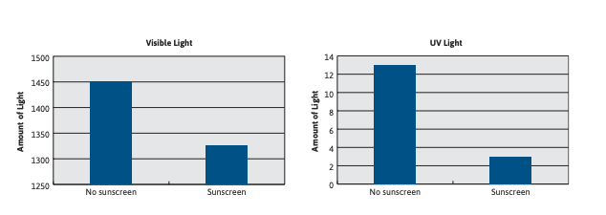  And/or share the data table from the TE and shown here:  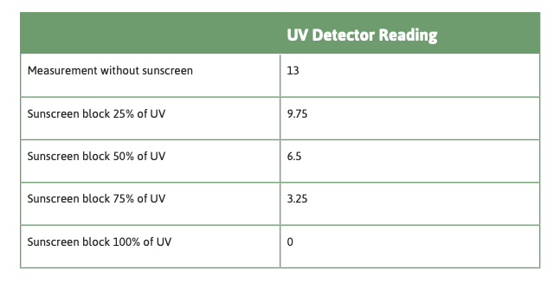  Key: UV light is another type of invisible light. Sunscreen/sunblock blocks damaging UV light, but blocks little or no visible light. | SE Activity 13.1, | SE Activity 13.1  Print PIs:  - Wavelength
Reading One | Nonvisible Light  Key: Real-world applications of electromagnetic waves: microwaves, radiowaves, x-rays. | SE Reading One | SE Reading One
Activity 13.2 | Given the likelihood of reduced time for remote learning, time could be reduced by skipping this activity; however, the phenomena in this activity are typically very interesting to Ss.  How Would the World Look if People Could See UV and IR Light?  Share PIs:  - Sun with Camera Lens  - Sun with UV Camera  - Sun with Infrared Camera  - Flowers  - Infrared Photography  Key: Real-world applications of electromagnetic waves and different uses. | SE Activity 13.2 | SE Activity 13.2  Print PIs:  - Sun with Camera Lens  - Sun with UV Camera  - Sun with Infrared Camera  - Flowers  - Infrared Photography
Checkpoint: Scientists’ understanding of the behavior of light enables them to use light and manipulate light for many purposes, and for scientists and engineers to develop tools and processes.

Appendix
Appendix 1  (0-1 day) | Sending Analog and Digital Signals | Download Appendix 1 Teaching Slides
ACTIVITY | TEACHING RECOMMENDATIONS | DIGITAL RESOURCES | PRINT RESOURCES | MATERIALS  FOR EACH STUDENT
Activity 1.1  Sending Analog and Digital Signals | This activity cannot be replicated remotely. If teachers choose to address differences between analog and digital signals, Reading One addresses that content (but with no hands-on investigation of the phenomenon).  Share PI: Communication Signals |  | Print PI:  Communication Signals
Reading One | Communicating with Analog and Digital Signals  Key: Digitized signals (sent as wave pulses) are a more reliable way to encode and transit information than are analog signals. | SE Reading One | SE Reading One

Appendix 2  (1 session) | The Solar System | Download Appendix 2 Teaching Slides
ACTIVITY | TEACHING RECOMMENDATIONS | DIGITAL RESOURCES | PRINT RESOURCES | MATERIALS  FOR EACH STUDENT
Activity 2.1  Studying Space | Appendices 2 and 3 address various aspects of the scale of the universe and the workings of the Earth-sun-moon system. These activities are placed here, at the end of the unit, as an opportunity for Ss to apply and extend what they have learned about light’s interaction with matter in the context of space science.  The emphasis of Activity 2.1 is scale properties. Ss are unable to build telescopes remotely given the materials needed. Instead, videos related to size and scale are widely available online, and may be the best remote-learning approach to this content. | SE Appendix Activity 2.1 | SE Appendix Activity 2.1
Reading One | Studying the Solar System  Key: Connects how astronomers study the solar system with what Ss have studied about the electromagnetic spectrum and wavelengths. | SE Reading One | SE Reading One
Activity 2.2  Scale Model of the Solar System | Share PI: Model of the Solar System  Demo the activity or share the Activity Video and use questions in the TE and SE for remote discussion. | SE Appendix Activity 2.2  Activity Video Apx 2.2. Scale Model of the Solar System | SE Appendix Activity 2.2  Print PI:  Model of the Solar System

Appendix 3  (2 sessions) | The Earth-Moon-Sun System | Download Appendix 3 Teaching Slides
ACTIVITY | TEACHING RECOMMENDATIONS | DIGITAL RESOURCES | PRINT RESOURCES | MATERIALS  FOR EACH STUDENT
Activity 3.1  Lunar Phases | Demo by building the model of the Earth-sun-moon system, if possible. Otherwise, share the Activity Video, as well as the additional video of the phenomenon of lunar phases.  Share PI: Moon Phases Composite  Key: What causes phases of the moon as viewed from Earth. | SE Appendix Activity 3.1  Activity Video Apx 3.1 Lunar Phases  Video: lunar phases | SE Appendix Activity 3.1  Print PI:  Moon Phases Composite
Reading One | Movements of the Moon  Key: The moon’s movement and how it is related to different events as seen from Earth. | SE Reading One | SE Reading One
Activity 3.2  Eclipses | Adapt the 3.1 model for this activity and demo for Ss, if possible. Otherwise, share the video that demonstrates the phenomenon of eclipses.  This lesson applies Ss understanding of light and shadow to the context of Earth-sun-moon phenomena.  Share PIs:  - Moon During Lunar Eclipse  - Sun During Solar Eclipse  - Earth During Solar Eclipse:  - Comparing Lunar and Solar Eclipses  - Partial Solar Eclipse  Key: What causes eclipses as viewed from Earth. | SE Appendix Activity 3.2  Activity Video Apx 3.2 Eclipses  Video: eclipses | SE Appendix Activity 3.2  Print PIs:  - Moon During Lunar Eclipse  - Sun During Solar Eclipse  - Earth During Solar Eclipse:  - Comparing Lunar and Solar Eclipses  - Partial Solar Eclipse
Activity 3.3  Seasons | Adapt the 3.2 model for this activity and demo for Ss, if possible. Otherwise, share the Activity Video and the video that addresses seasons.  Share PI: Earth’s Distance from the Sun  Key: What causes Earth’s seasons: Differential intensity of sunlight on the Earth across the year, as a result of Earth’s tilted axis. | SE Appendix Activity 3.3  Video: seasons  Activity Video Apx 3.3. Seasons | SE Appendix Activity 3.3  Print PI  Earth’s Distance from the Sun

SUMMATIVE ASSESSMENT: The SE questions for Appendix Activity 3.2 provide an opportunity to assess Ss understanding of light’s interaction with matter as they apply that understanding to space science phenomena.

Teachers might choose to emphasize only a portion of this as a final assessment, given what they are able to teach and what Ss are actually able to do during this remotely taught unit.

